Oran

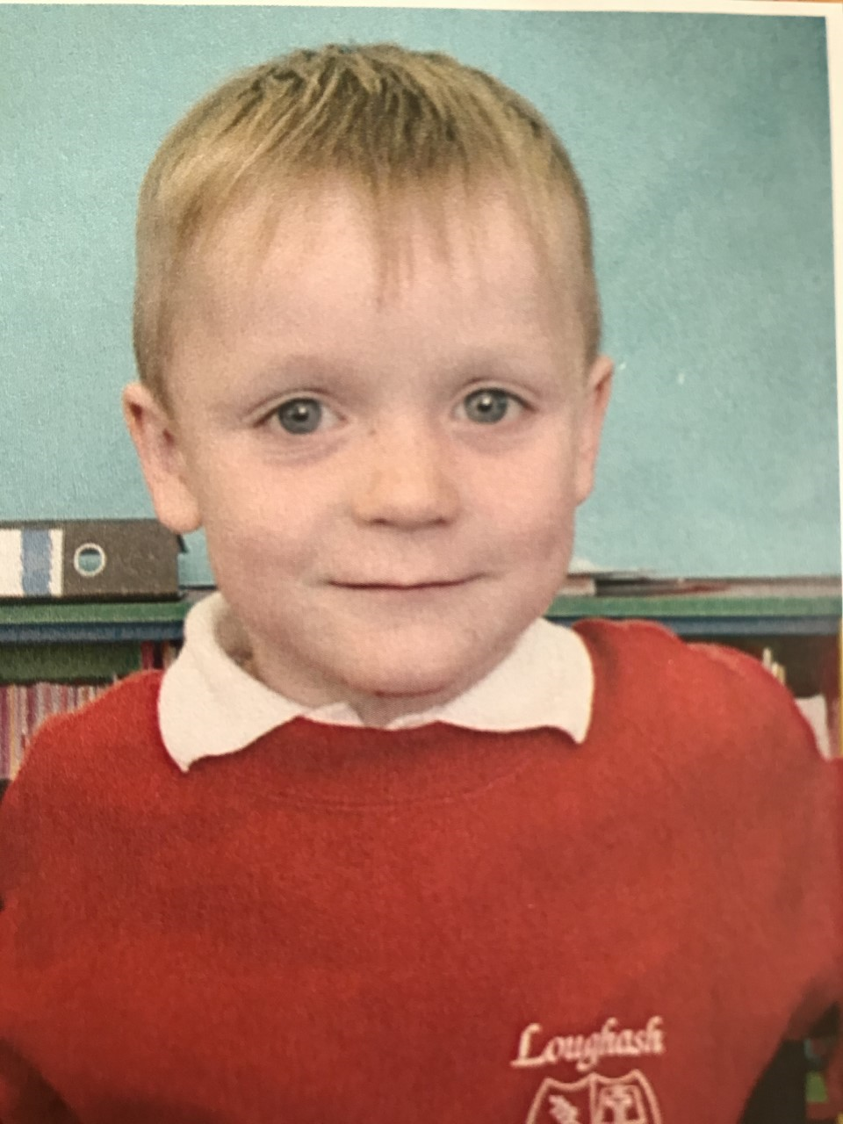

**Special Message/ Quote to Your Classmates**

Hope to see everyone soon

**Your Hopes and Aspirations for the Future**

**To play for Tyrone and live a great life**

**Favourite Primary School Memory**

When Eoin and I completely covered the playground in rock salt!

