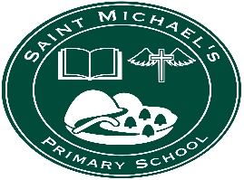
St Michael’s PS, Dunnamanagh

11th June 2020,
Dear Parents,
Unfortunately, I am unable to share definite information with you at this stage regarding the re-opening of St Michael’s. I know there is speculation in the media, but we need information from DE/ EA, which has not yet been confirmed or issued. I assure you, I will supply this information as soon as I can. What I can say that it is likely that there will be a ‘blended approach’ to learning. This means face-to-face teaching in the classroom and on-line teaching.
- If this blended learning involves having different groups of children in school at different times. We will ensure all of the children in a family are in on the same day.
- To meet the on-line component of this approach, we will most likely use google classroom as the platform.
- Staff are currently undertaking tutorials and exploring how to use google classroom. Our aim being to have one lesson with our current classes before the end of term to ensure both pupils and staff can firstly, access and then, work using this platform. Teachers will let you know about this via the school website. Miss Devine and the P7s are already ‘ahead of the posse’ as they have been using google classroom for many weeks. Miss Devine undertook this commitment to ensure that P7s were familiar with the learning environment that they would have to use in post-primary.
- In relation, to on-line access at home. Come the new school year, we will need to ensure all our pupils have on-line access for learning in the new school year and will do everything we can to assist you with this. EA are looking into this matter.
- I currently do not have information relating to:
  - return to school date
  - return to school in terms of which year groups will be first etc.,
  - confirmation of blended learning format
  - transport
  - canteen.
However, I assure you I will give you information as soon as I can.

- Please continue to regularly check out the website for information
I hope you all continue safe and well.
Regards,
J Carlin (Mrs)
Principal

