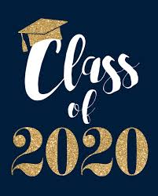 Rebecca

**Special Message/ Quote to Your Classmates**

**Believe in Yourselves**

**Your Hopes and Aspirations for the Future**

**To go to university and study care of animals.**

**To be successful.**

**Favourite Primary School Memory**

**Meeting Miss McCauley**

