Brian



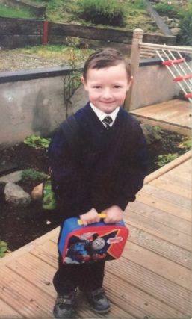

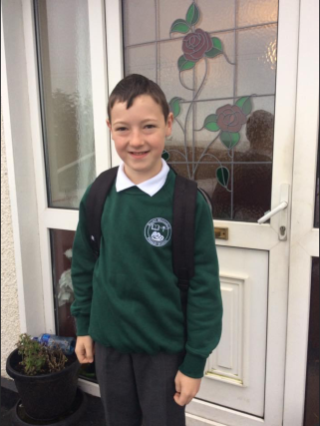

**Special Message/ Quote to Your Classmates**

Thank you to my P.7 friends who were wonderful classmates. Good luck in your new Secondary School.

**Your Hopes and Aspirations for the Future**

My hopes and aspirations for the future is to do well at my new Secondary School, get good grades, hope to keep working hard in my Karate to do well, help my Dad on the farm and to go to Greenmount College when I leave school.

**Favourite Primary School Memory**

When I was in P.6 Gloria came to our school to make the paverpol with us. I made a lovely sculpture with my Dad.

When I was in P.6 we went to Rathlin Island for our school trip, we went by a coach and then by a boat to get there. It was a great day!