Merissa

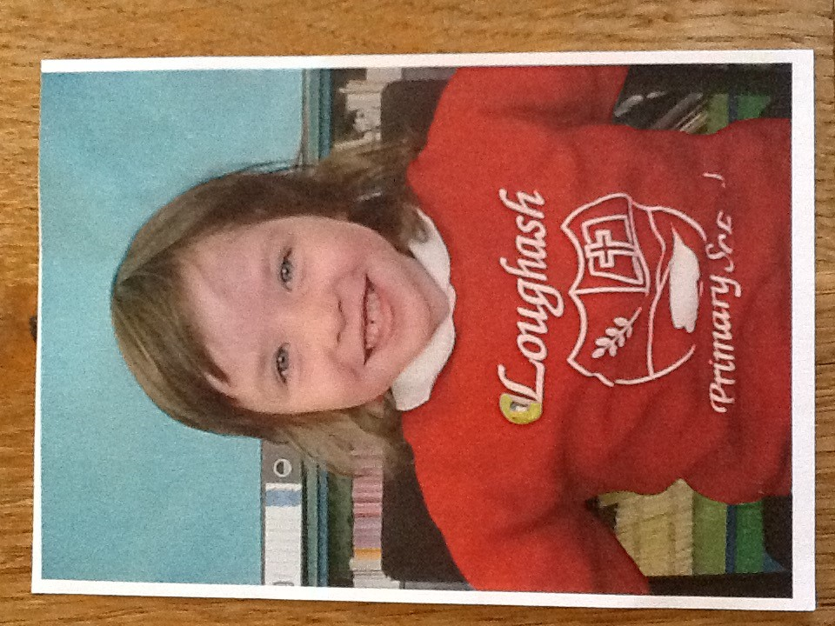

**Special Message/ Quote to Your Classmates**

Good luck in your future

**Your Hopes and Aspirations for the Future**

Take every opportunity in life and become a farmeress.

**Favourite Primary School Memory**

Starting St. Michael’s P.S

