Lily

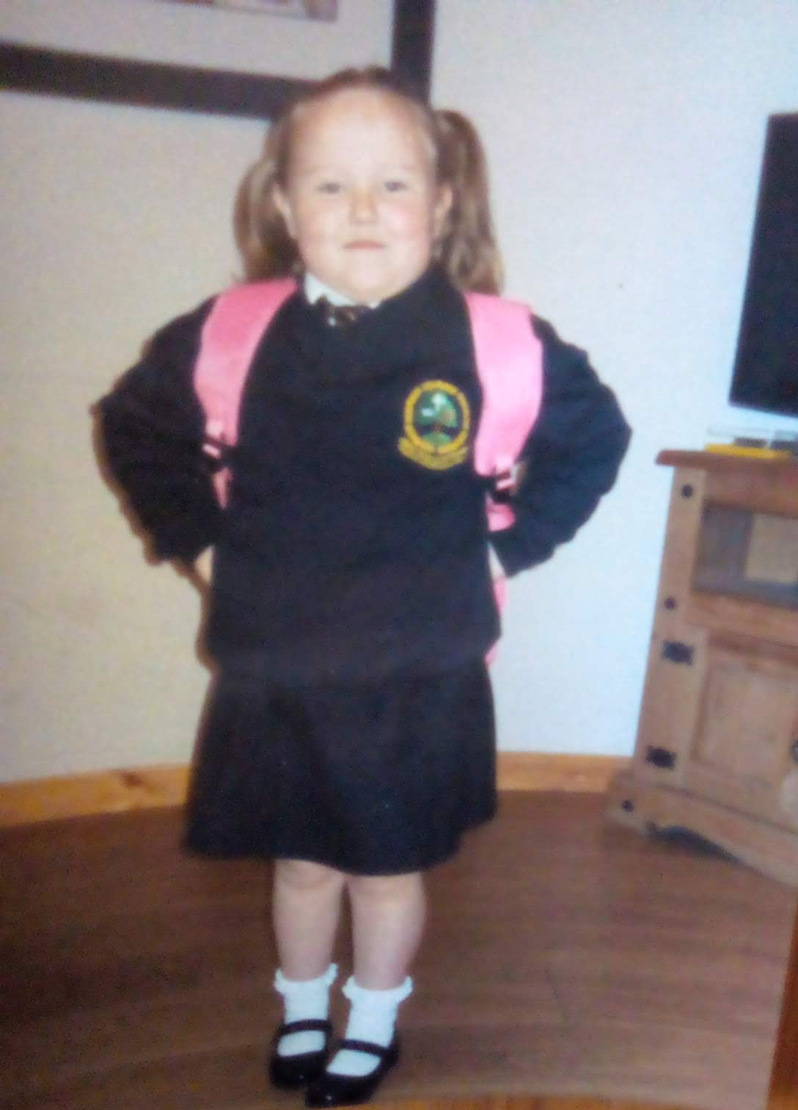

**Special Message/ Quote to Your Classmates**

**Enjoy the next chapter, even though some of us will not be together, I wish you all good luck! #friend’s #memories**

**Your Hopes and Aspirations for the Future**

**I hope to attend the Holy Cross College in Strabane. I am looking forward to moving to big school with some of my friends and to making new friends. I am going to work hard so I can get to university to become a primary school teacher. I hope that I will get to meet Niall Horan along the way! Lol!**

**Favourite Primary School Memory**

**My favourite Primary school moment was when we reared pheasant baby chicks. We kept them in an incubator until they hatched into fluffy bundles off joy. Not all survived but the ones that did we fed and kept in a hutch and when they had grown, we gave them to Paddy Sherrin so the pheasants could live happily in the countryside of Altishane.**

