Aoife

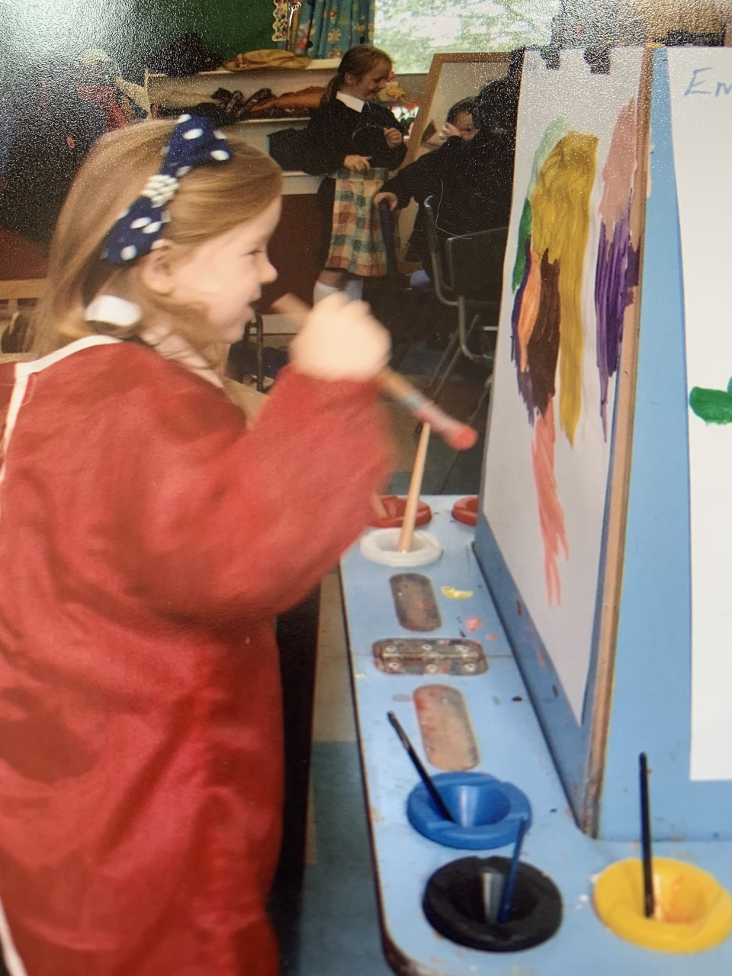

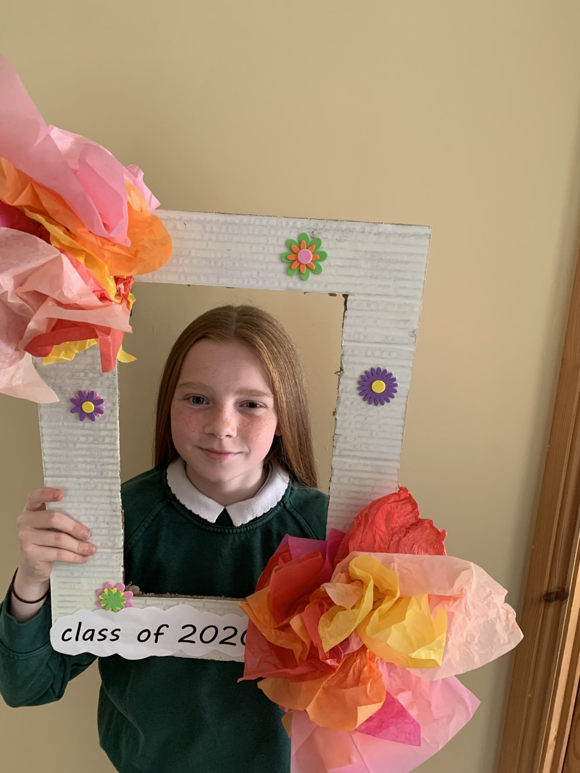

**Special Message/ Quote to Your Classmates**

**Good Luck Everyone in your New School**

**A day without laughter is a day wasted so laugh and be yourself**

**A**

**Your Hopes and Aspirations for the Future**

**I would love to play Gaelic for Tyrone**

**I would love to travel the world**

**Be kind to everyone and Enjoy Life**

**Favourite Primary School Memory**

**Before we left Altishane we went to Rathlin Island it was brilliant**