**Corran**

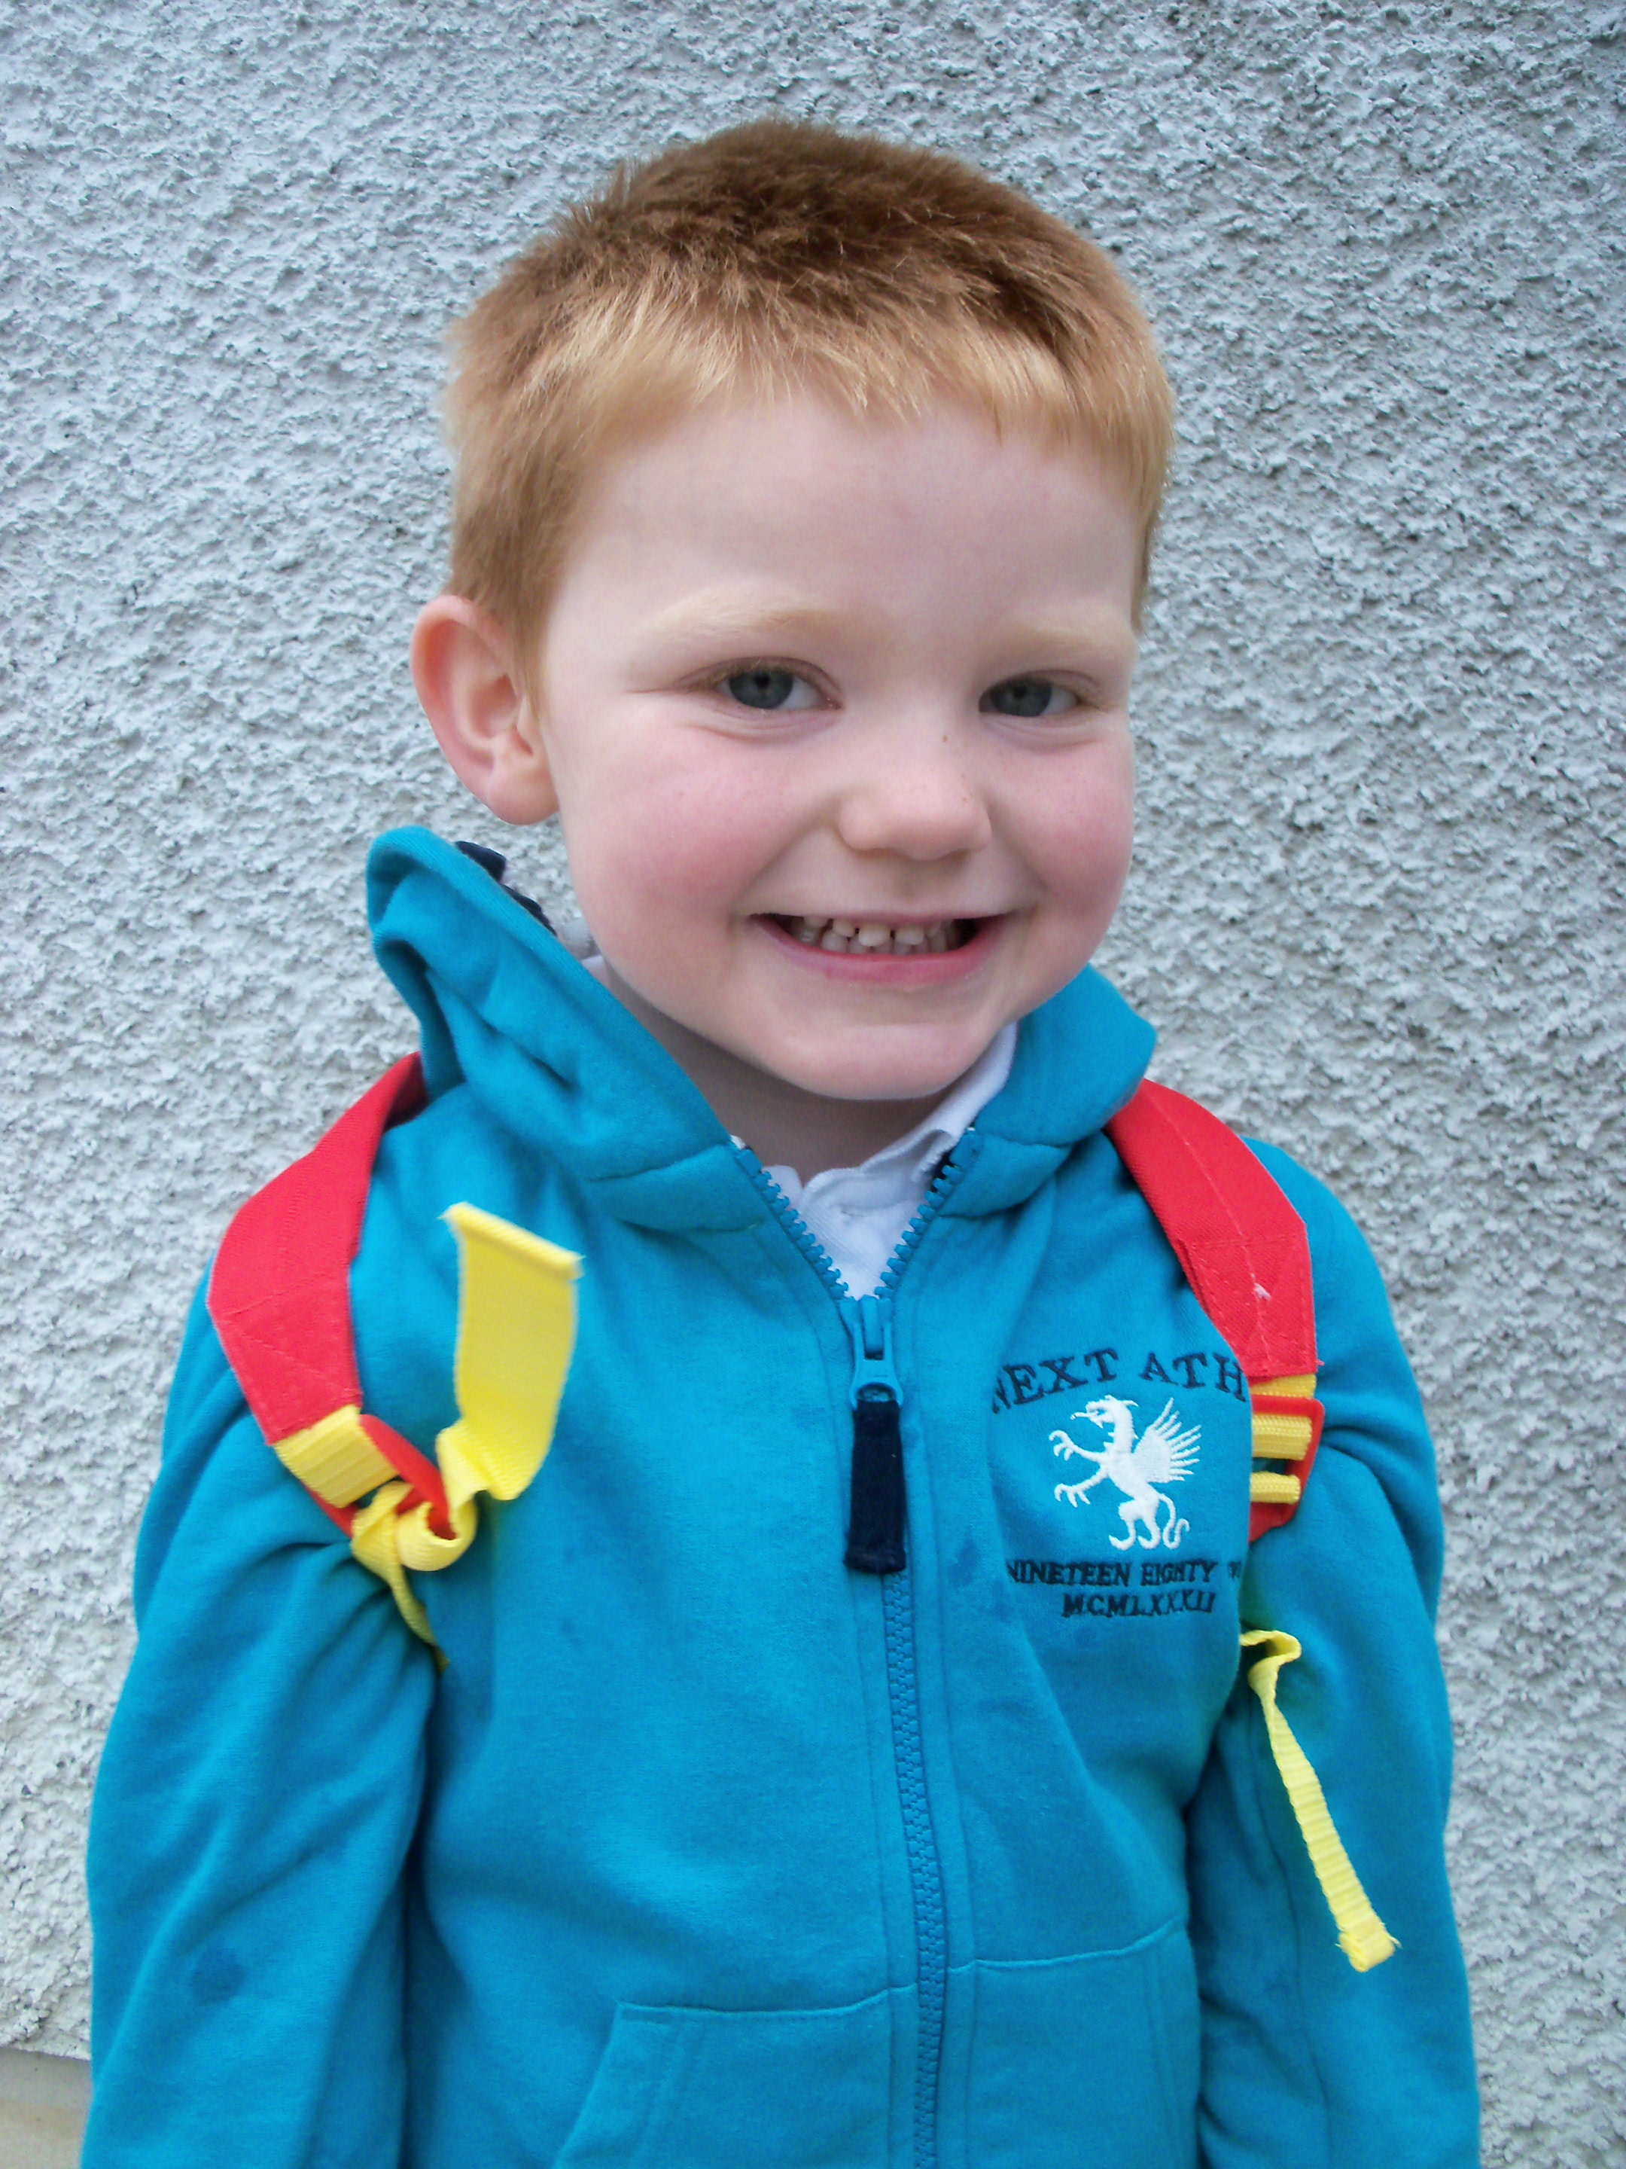

**Special Message/ Quote to Your Classmates**

Always believe in yourself!

**Your Hopes and Aspirations for the Future**

I’d like to become a Blackface sheep breeder and drive a lorry for a day.

**Favourite Primary School Memory**

My favourite memory was when I was Chairperson of the Eco Council in Loughash PS and we won the Green Flag for the second time in a row.

