Dárá

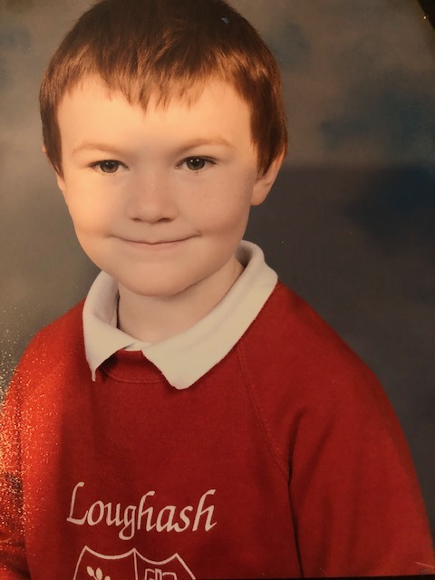de Photograph

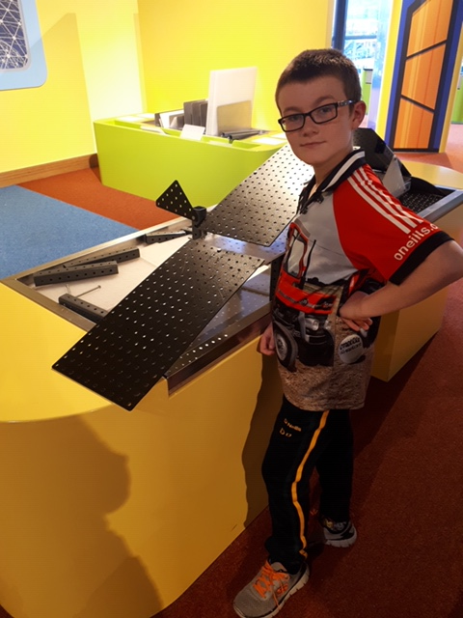

**Special Message/ Quote to Your Classmates**

Keep her lit!

**Your Hopes and Aspirations for the Future**

I hope to be as good at farming as my Daddy is.

**Favourite Primary School Memory**

My favourite school memory is when Mrs Carlin organised the Ice-cream van to come to school for sports day.