Eoin

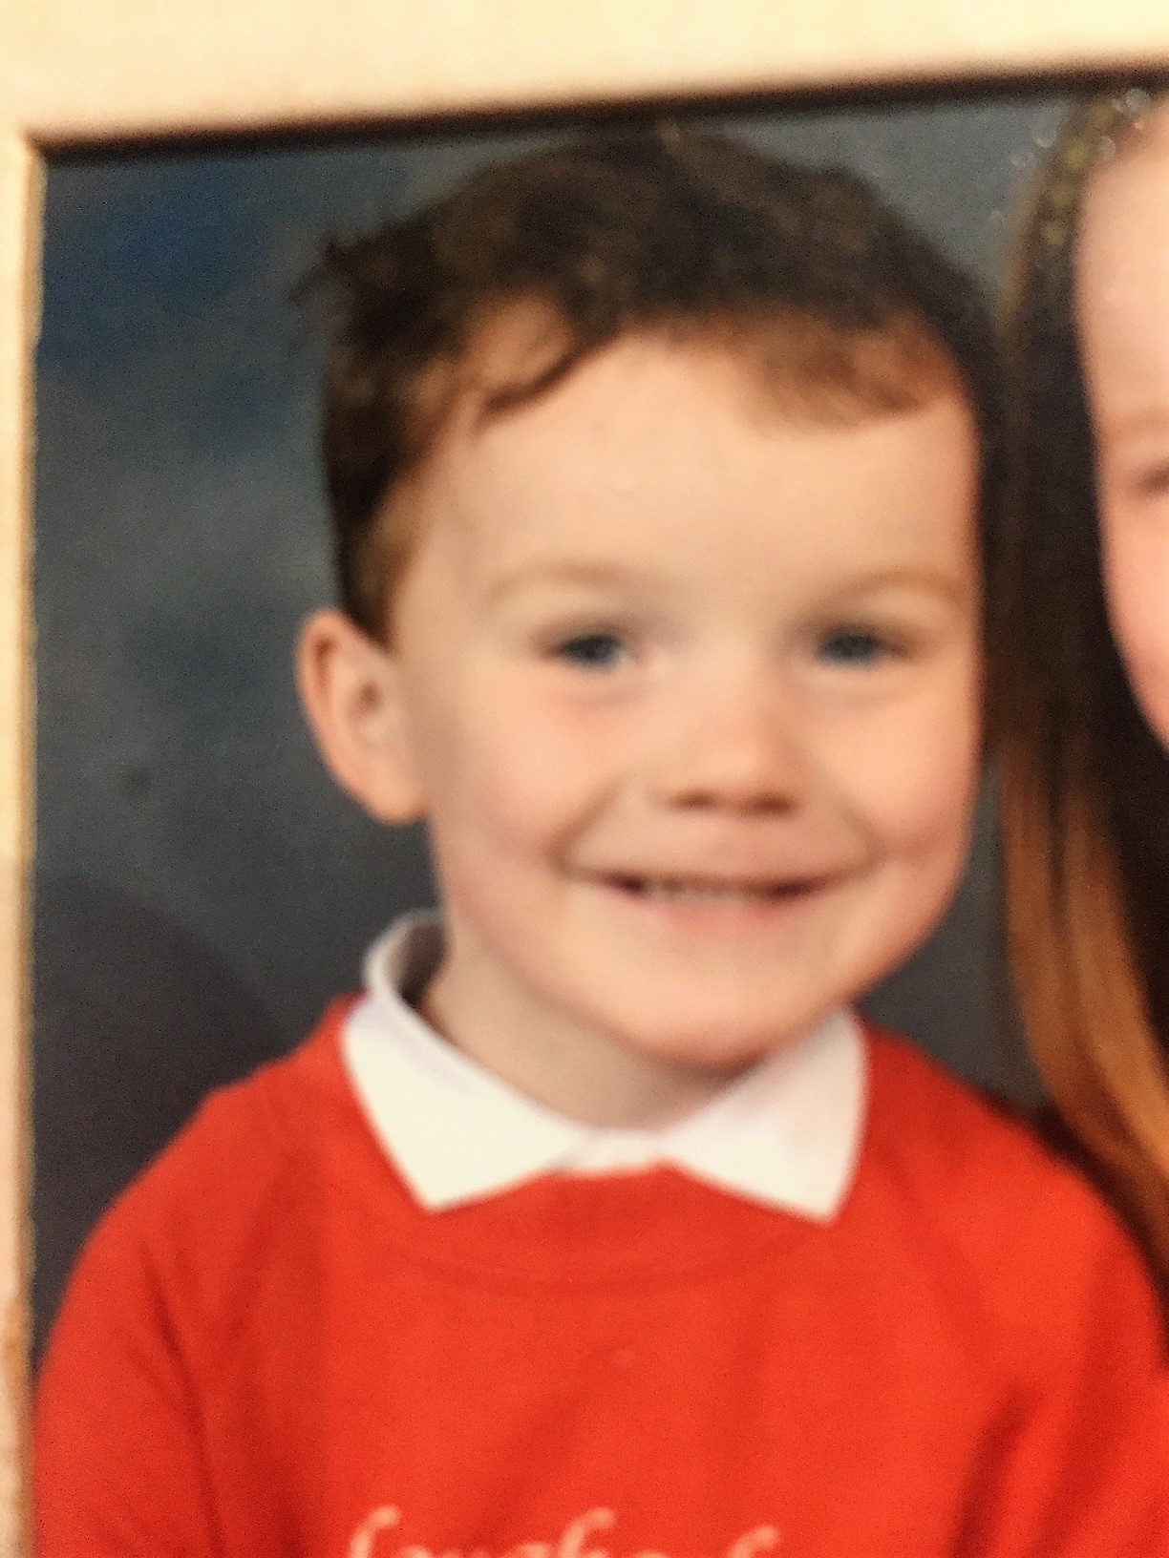

**Special Message/ Quote to Your Classmates**

**Never Give UP!**

**Your Hopes and Aspirations for the Future**

**To do well at the Christian Brothers & continue enjoying playing football!**

**Favourite Primary School Memory**

**Gaelic tournament at Garvaghey**

