Katelyn

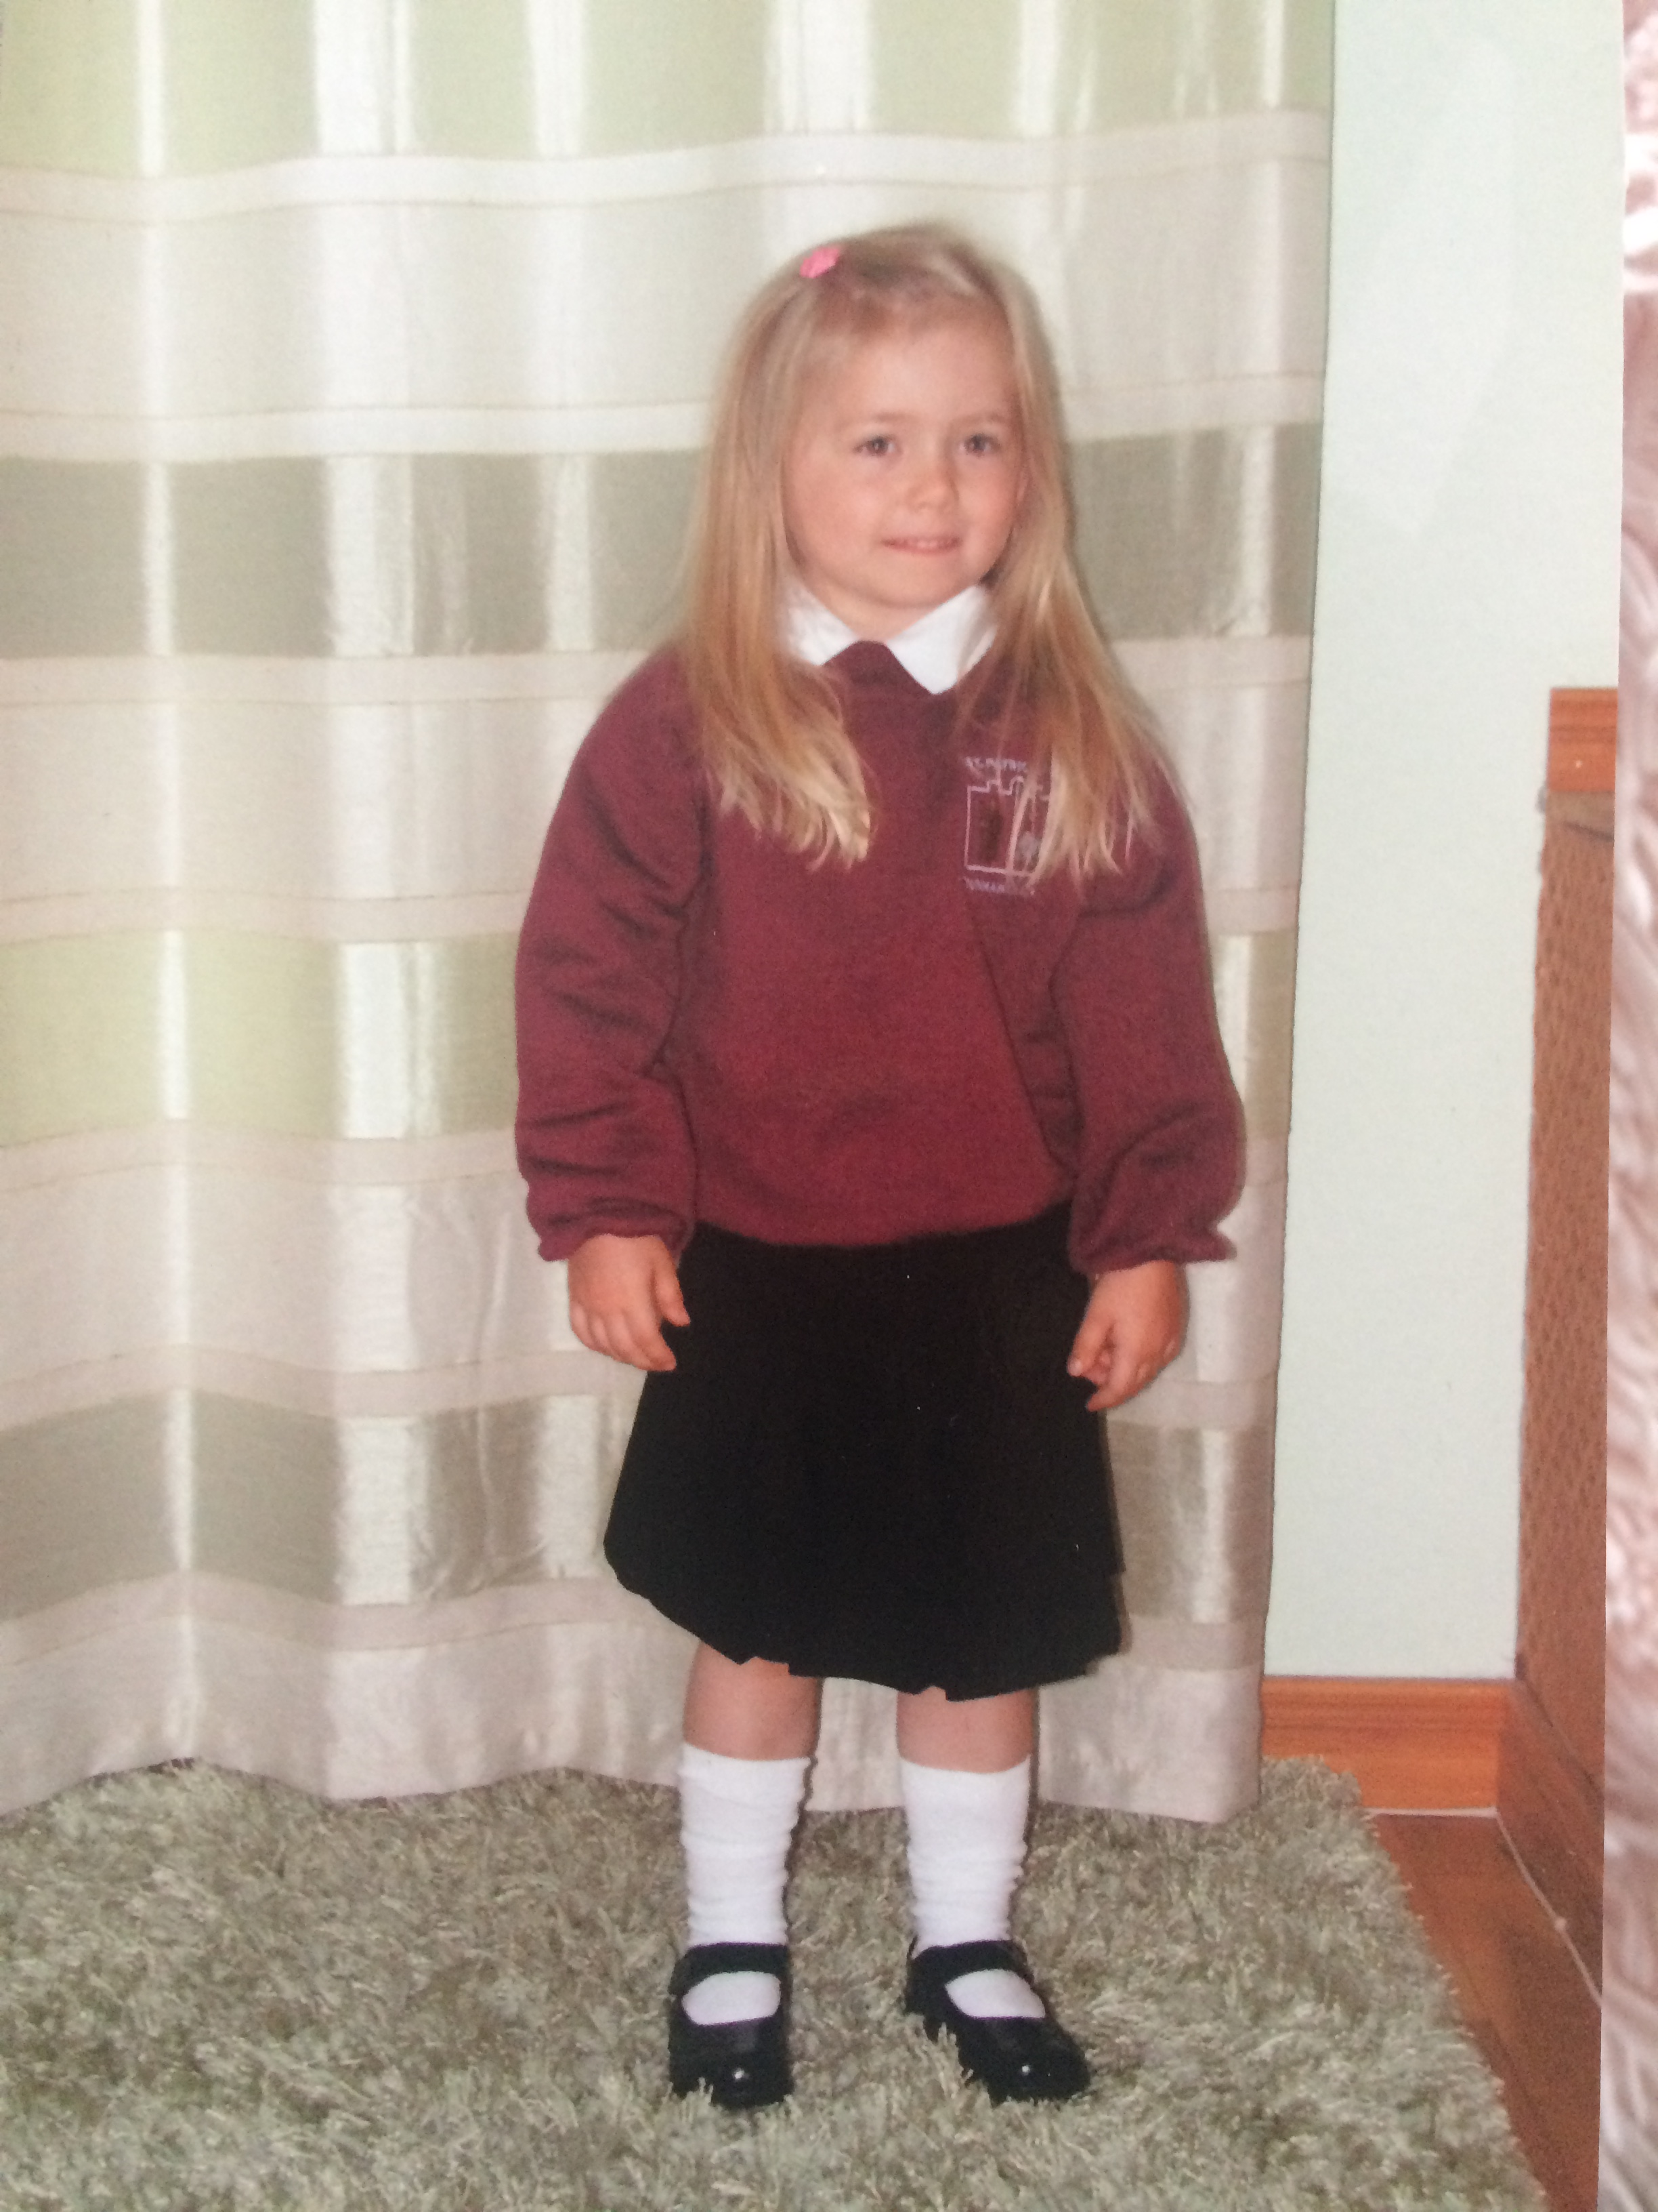

**Special Message/ Quote to Your Classmates**

**Nothing is impossible the word itself says I’m possible.**

**Your Hopes and Aspirations for the Future**

**To do well in school and become a vet.**

**To have good friends.**

**Favourite Primary School Memory**

**School trip to Lurgybrack fun farm and the Titanic and the Zoo in Belfast with my classmates.**

