Dabhán

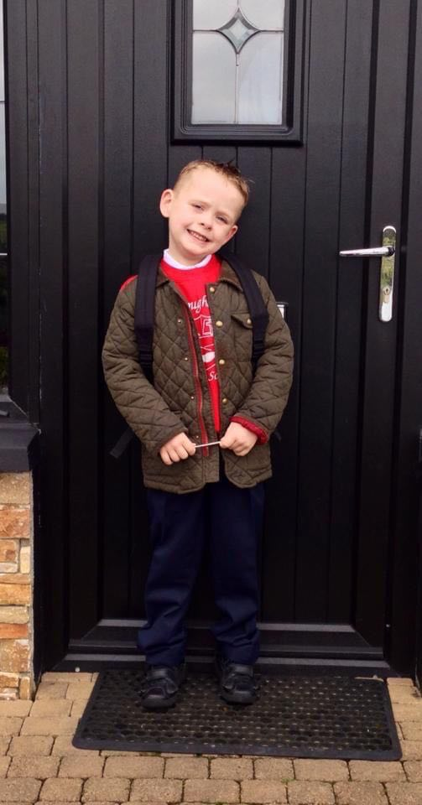

**Special Message/ Quote to Your Classmates**

Good luck lads, it’s been good craic!

**Your Hopes and Aspirations for the Future**

To own a business genetically modifying genes for AI in cattle and to farm in my spare time.

**Favourite Primary School Memory**

Miss Devine’s brother came in and we created a working lightbulb through electrical engineering, that was really fun!

