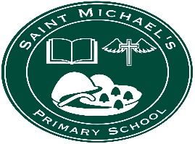
St Michael’s PS, Dunnamanagh
49, Lisnaragh Rd
Dunnamanagh, Strabane
Co Tyrone BT82 0QN

1st February 2021

Dear Parent,

I hope all is well with you and your families.
Given the recent announcement that schools will remain closed until at least early March we would like to gauge how the remote learning, which we are providing is working out. Therefore, we would be grateful if you would complete the very short survey of just 5 questions, which we have made available at:
https://s.surveyplanet.com/XgkDR_sOJ

St Michael's Primary School Parent Remote Learning Survey
Welcome, Please Take a Few Minutes to Complete This Survey.
s.surveyplanet.com


The survey will be anonymous. It will be open from Monday 1st February 3pm until Monday 8th February 3pm.

Thank you in anticipation of your help.
J Carlin (Mrs)
Principal

