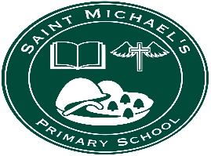
St Michael’s PS,
49, Lisnaragh Rd
Dunnamanagh, Strabane
Co Tyrone BT82 0QN

For the attention of parents with children who will be starting primary one in September 2022:

EA have published information about the primary one admissions procedure and admissions criteria on their website https://www.eani.org.uk/admissions

The primary one application process opens online on Monday 10th January 2022.

We are keen to promote the school and reach as many families as possible with this important information. So, if you know of any families with children who are eligible to enrol in St Michael’s Primary School in September 2022 please share this information with them.

Given the ongoing difficulties with Covid, we will be posting an ‘Open Day’ video on our school website: www.stmichaelspsdunnamanagh.com in early January. You can also ring the school to arrange an appointment if you wish to view the school. Viewings will take place between 3.15 and 4pm Monday 10th Jan – Thursday 13th January.
If you have any queries, please do not hesitate to contact us on 71 398397.

