Dear Parents,
Please find attached your child’s schedule for Week 2. All activities listed can be extended using the online activities already provided. Again, please ensure children follow the online safety guidelines and exercise caution when using electronic devices. At the time of writing this all websites/ apps are free registration however that can change on a daily basis. Children need a good balance of worksheet activities and online activities. Don’t forget to stress the importance of good letter and number formation during completion of activities.
Primary 6 pupils should ensure that they are completing one transfer paper in English and Maths per week in addition to the material provided. I request that Primary 6 also complete the Numeracy transfer homework booklet that they had been working on prior to the break.
RTE to broadcast ‘School on TV’ from Monday
This will run from 11 a.m. – 12 p.m. Monday to Friday on RTE 2 aimed at children from Primary 3 to Primary 7. Supporting worksheets and other material will be on RTE.ie/learn. Some content may be delivered in Irish. This may be a much needed educational break for parents!

Numeracy Support
- If you are having difficulty explaining any mathematical concepts to your children this week Carol Vorderman is doing online maths tutorials www.themathsfactor.com
- Education City is now up and running.
- Mathletics – I hope you were able to download your free Mathletics booklet from https://www.mathletics.com/uk/resources/fun-engaging-student-workbooks/success/ , if not, please do so using the guidance for support. The teacher download contains all the answers to the activities. Only print specified pages in schedule as they are large documents.
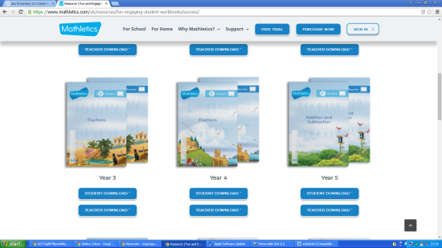
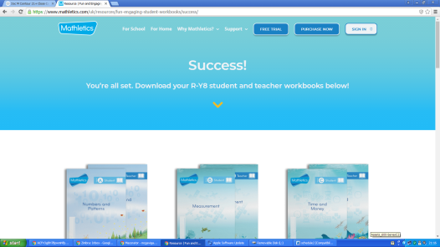

Primary 6 Booklet

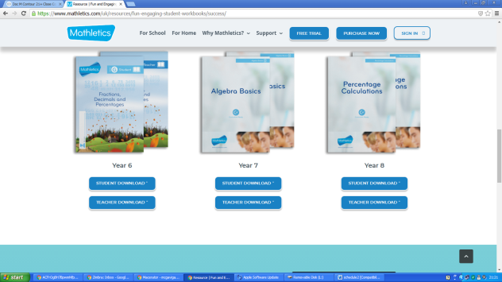

Primary 7 Booklet

WAU
All World Around Us activities will be set from Northern Ireland Water resources this week www.niwater.com/sitefiles/resources/pdf/h20-worksheet.pdf please download and print pages 19-36

Religious Studies Programme
We have been granted free access for all our parents on a temporary basis to our Grow in Love Programme. See details on the weekly schedule.
Login to Grow in Love – Religion Programme is: www.growinlove.ie
Email: trial@growinlove.ie
Password: growinlove
Select Primary 6 for Year 6 and access the ebook on the right hand side of the screen, similarly do the same for Year7.
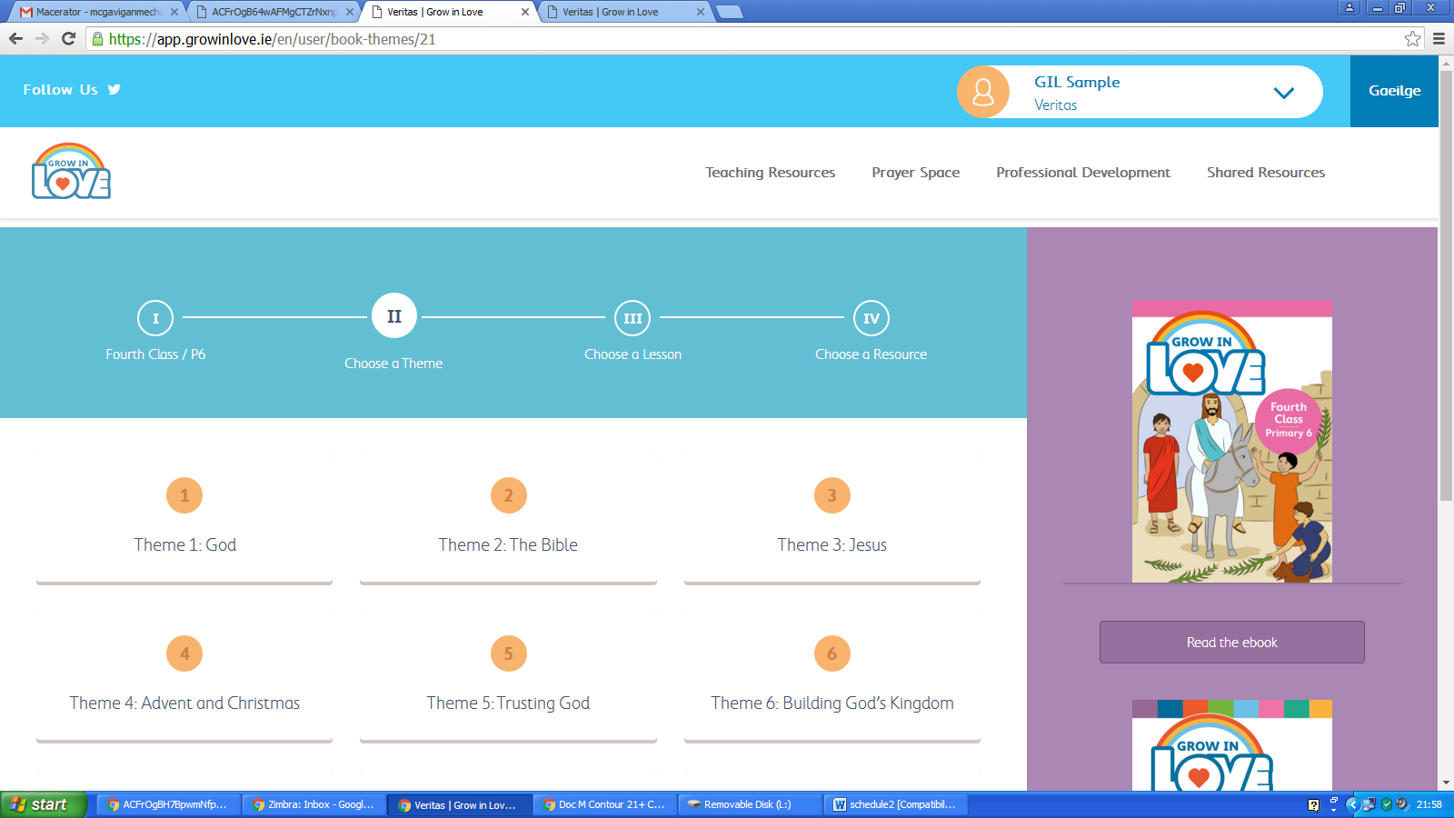
Pupil Wellbeing
- I hope you have been able to access the Wellread App supplied free to us from the Verbal Arts Centre, it has some excellent material.
- Relax Kids have a lovely pack full of great ideas and resources for free download http://www.relaxkids.com/calm-pack.
- Autism NI have created a social story to help children understand self- isolation and why it is important to keep everyone safe. www.autismni.org/why-do-i-have-to-stay-at-home.html The language within this booklet is perfectly pitched towards children of all ages and abilities.
- Autism NI have also created a fantastic ‘Anxiety Resource Pack,’ which can be downloaded from www.autismni.org/anxiety-resource-pack.html
- A list of free Apps that parents can download for their children to manage their self-care and emotional well-being : www.autismni.org/free-apps-for-children---self-care-and-emotional-well-being.html
We Are Vertigo - They are offering the chance to win 50 passes for a Primary 7 party when this all comes to an end. Why not like, share and tag on facebook and see if we can give our children something to look forward to.
Take Care,
Miss Devine and Miss McCauley
Spelling Lists for Week 2
‘N’ Sound - Variations: n, nn, kn, gn, pn
Year 6 Spelling List

Negative
Knowingly
Announce
Disconnect
Neglect
Sovereign
Mnemonic
Naturally
Conscience
Science
Nursery
Gnarled
Unknown
Nation
Connect
Gnawing
Conscious
Resign

Year 7 Spelling List

Pneumonia
Campaign
Nervous
Pneumatic
Assign
Novelty
Acknowledge
Neither
Innocent
Innocence
Nocturnal
Connoisseur
Champagne
Condensation
Condescend
Malign
Cologne
Connive

 | Monday | Tuesday | Wednesday | Thursday | Friday
9-15 -9-30 | Phonics  Scaffold Text- see attached | Phonics  Word sort into the different variations | Phonics  Word Work See Attached | Phonics  Select 5 spelling words, use a dictionary to find their meanings. Write 5 complex sentences using these words. | Phonics  Spelling Test
9-30-9-45 | Mental Maths  Complete Mental Arithmetic Book Section A/B or C or Mental Maths Daily test | Mental Maths  cgpbooks.co.uk  Test 2  11+ Online 10 Minute Tests - Maths | Mental Maths  Complete Mental Arithmetic Book Section A/B or C or Mental Maths Daily test | Mental Maths  Top Marks Daily 10  Select Level 5 P6  Level 6 P7 Select Doubles/Halves: Doubles Ones and Tenths | Mental Maths  Complete Mental Arithmetic Book Section A/B or C or Mental Maths Daily test
9-45-10.30 | Religion  Grow in Love Details in above notes  P6 – Read pg43+44 Complete activities pg44  P7 – Read page 66 and 67 | STEM - Create a Lego Marble Maze – see examples attached. | Religion  Grow in Love Details in above notes  P6 – Read pg45+46 Complete activity pg46  P7 – Read page 68. Write out the poem on pg69 illustrate to show understanding. | PATHS  Write a letter/note to someone at home – see attached notes | PE – With supervision from parents try Annie Deery’s yoga class for kids. She can be found on facebook – Annie Deery.
Break
11.00 -11.45 | Literacy  Complete one of your comprehension activities found within your pack. | Literacy  Reading/ Research  See notes attached | Literacy  Report Writing  See notes attached | Literacy  Prefixes  See Attached | Literacy  Complete one of your cloze procedures found within your pack.
11.45-12.00 | Movement Break  PLEASE try GoNoddle this week, children will LOVE it.  https://family.gonoodle.com | Movement Break  PLEASE try GoNoddle this week, children will LOVE it.  https://family.gonoodle.com | Movement Break  PLEASE try GoNoddle this week, children will LOVE it.  https://family.gonoodle.com | Movement Break  PLEASE try GoNoddle this week, children will LOVE it.  https://family.gonoodle.com | Movement Break  PLEASE try GoNoddle this week, children will LOVE it.  https://family.gonoodle.com
12.00 – 12.45 | Numeracy  Number – Mathletics Booklets  P6 pgs 22- 25  P7 pgs 22, 23, 26+28 | Numeracy  Measures – Time See attached | Numeracy  Number – Mathletics Booklets  P6 pgs 28+29  P7 pgs 38, 39+40 | Numeracy  Data Handling  See attached | Numeracy  Problem Solving  See Attached
Lunch
1.30-2.30 | WAU – Northern Ireland Water Booklet  P19-22 | Art  Draw and paint/colour an otter. Don’t forget about the background | PE –PE with Joe Wicks – Youtube – try one of his classes | WAU – Northern Ireland Water Booklet  pg29-36 | Golden Time  Or why not do some jobs around the house to help out ??
2.30 – 3.00 | Accelerated Reading  oxfordowl.co.uk/for-home/  Have additional eBooks if you require extra reading material. | Accelerated Reading  oxfordowl.co.uk/for-home/  Have additional eBooks if you require extra reading material. | Accelerated Reading  oxfordowl.co.uk/for-home/  Have additional eBooks if you require extra reading material. | Accelerated Reading  oxfordowl.co.uk/for-home/  Have additional eBooks if you require extra reading material. | Accelerated Reading  oxfordowl.co.uk/for-home/  Have additional eBooks if you require extra reading material.

Monday- Phonics
Primary 6 Scaffold Text

Stage 5 and 6 – The ‘n’ Sound

Read the text. Can you find any ‘n’ words? Look for n, nn, kn or gn.
Remember to read the word to check it has the right sound before you highlight it.

Nerves gnawed at the squire’s stomach as he prepared to kneel. This panic was a novel feeling for him. Now, he was to be made a knight. Knights needed to know how to defend and attack castles. They had to be ready to travel to foreign places on quests. They had to have knowledge of battles and they had to swear an oath. The nobles watched as King Arthur (for it was the time of his reign) laid his sword on the squire’s shoulders. Then the squire stood up, a new knight. His father came over to congratulate him; he took his son’s strong hand in his own gnarled one. The knight could see that his father had grown weaker and thinner; he could feel his bony knuckles. The old man patted him on the back, smiled and said, ‘Hello Sir!’

Monday Phonics
Primary 7 Scaffold Text
Stage 5 and 6 –The ‘n’ Sound
Read the text. Can you find any ‘n’ words? Look for n, nn, kn or gn. Remember to read the word to check it has the right sound before you highlight it.
It was nearly noon, when I heard a loud knocking on the front door. When I went to answer it, my friend Natalie was standing on the doorstep. She said that she had been trying to ring me but I explained that I had disconnected my phone from the power. Natalie said they had announced that the dates of the junior tennis competition were being brought forward and it was now happening next month. Her news had a negative impact on me. I had always dreamed of being the winner of this tournament but I knew that I had been neglecting my playing recently. My exams were beginning soon and I had knowingly taken a step back from my favourite sport to give me more time to study. Now, the opportunity to compete with the best players from across the nation was coming up and I was not ready. I felt very disappointed and anxiety began gnawing at my stomach. I made the connection that if the competition began next month, the finals would be taking place in the middle of my exams. I knew I would have to resign myself to the idea that I could not compete this year.

Wednesday Phonics – P6
Stages 5 and 6, The ‘n’ Sound
Select words containing your sound/s of the week to complete the answers.

1. Bone at the finger joint:
2. Small two-winged fly:
3. Belonging to or involving countries other than your own:
4. Bitten and chewed:
5. A king or queen’s rule:
6. Rough, twisted and knobbly:
7. To grind teeth together:
8. Narrow straps to guide a horse:
9. Facts known by a person:
10. Slimmer:

Anagrams
11. kingth
12. kenel
13. nokw
14. anir

Wednesday Phonics – P7
Stages 5 and 6, The ‘n’ Sound
Select words containing your sound/s of the week to complete the answers.

1. Not to take proper care of, to fail to do:
2. To undo or break a connection:
3. Royal ruler of a country:
4. To make known publicly.
5. The start:
6. To give up office or a job:
7. A wildebeest
8. Join:
9. Biting or chewing steadily
10. Deliberately:

Anagrams:
11. sunrery
12. kingnock
13. gun
14. nownunk

Tuesday - Literacy for Primary 6 and 7
Today you are going to use three different sources to research an otter or alternatively you can select an animal whose habitat is found on a river bank.
https://kids.nationalgeographic.com/animals/mammals/river-otter/
https://www.discoverwildlife.com/animal-facts/mammals/facts-about-otter/
https://kids.kiddle.co/Otter
You decide how you wish to record your notes, perhaps using a mind map or a table. Find below an example.

Name of Animal

Classification:

Appearance:

Habitat:

Diet:

Behaviour:

Lifespan:

Reproduction: Gestation period, name of their young, how long their young remains with their parent/s.
Other Important Information:

Wednesday – Literacy Primary 6 and 7
Report Writing – Ensure good letter formation throughout your written piece. Do not copy chunks from the internet, you must reword/summarise what you read. Below, find some guidance on how to write your report.
Don’t forget about the features of report writing:
- Title
- Classification: a general of classifying statement.
- Description: accurate and detailed
- Conclusion: A comment about the content of the report
- Use the language features: factual language, the third person and information organised into paragraphs.

Thursday – Literacy P6

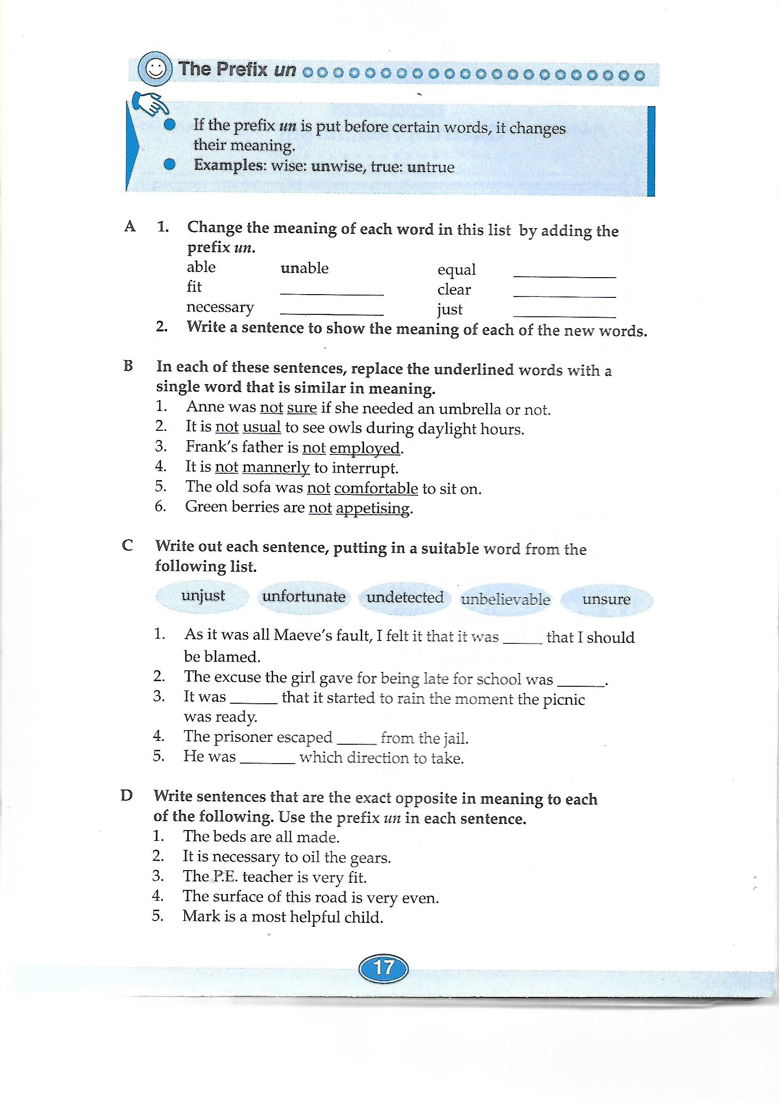
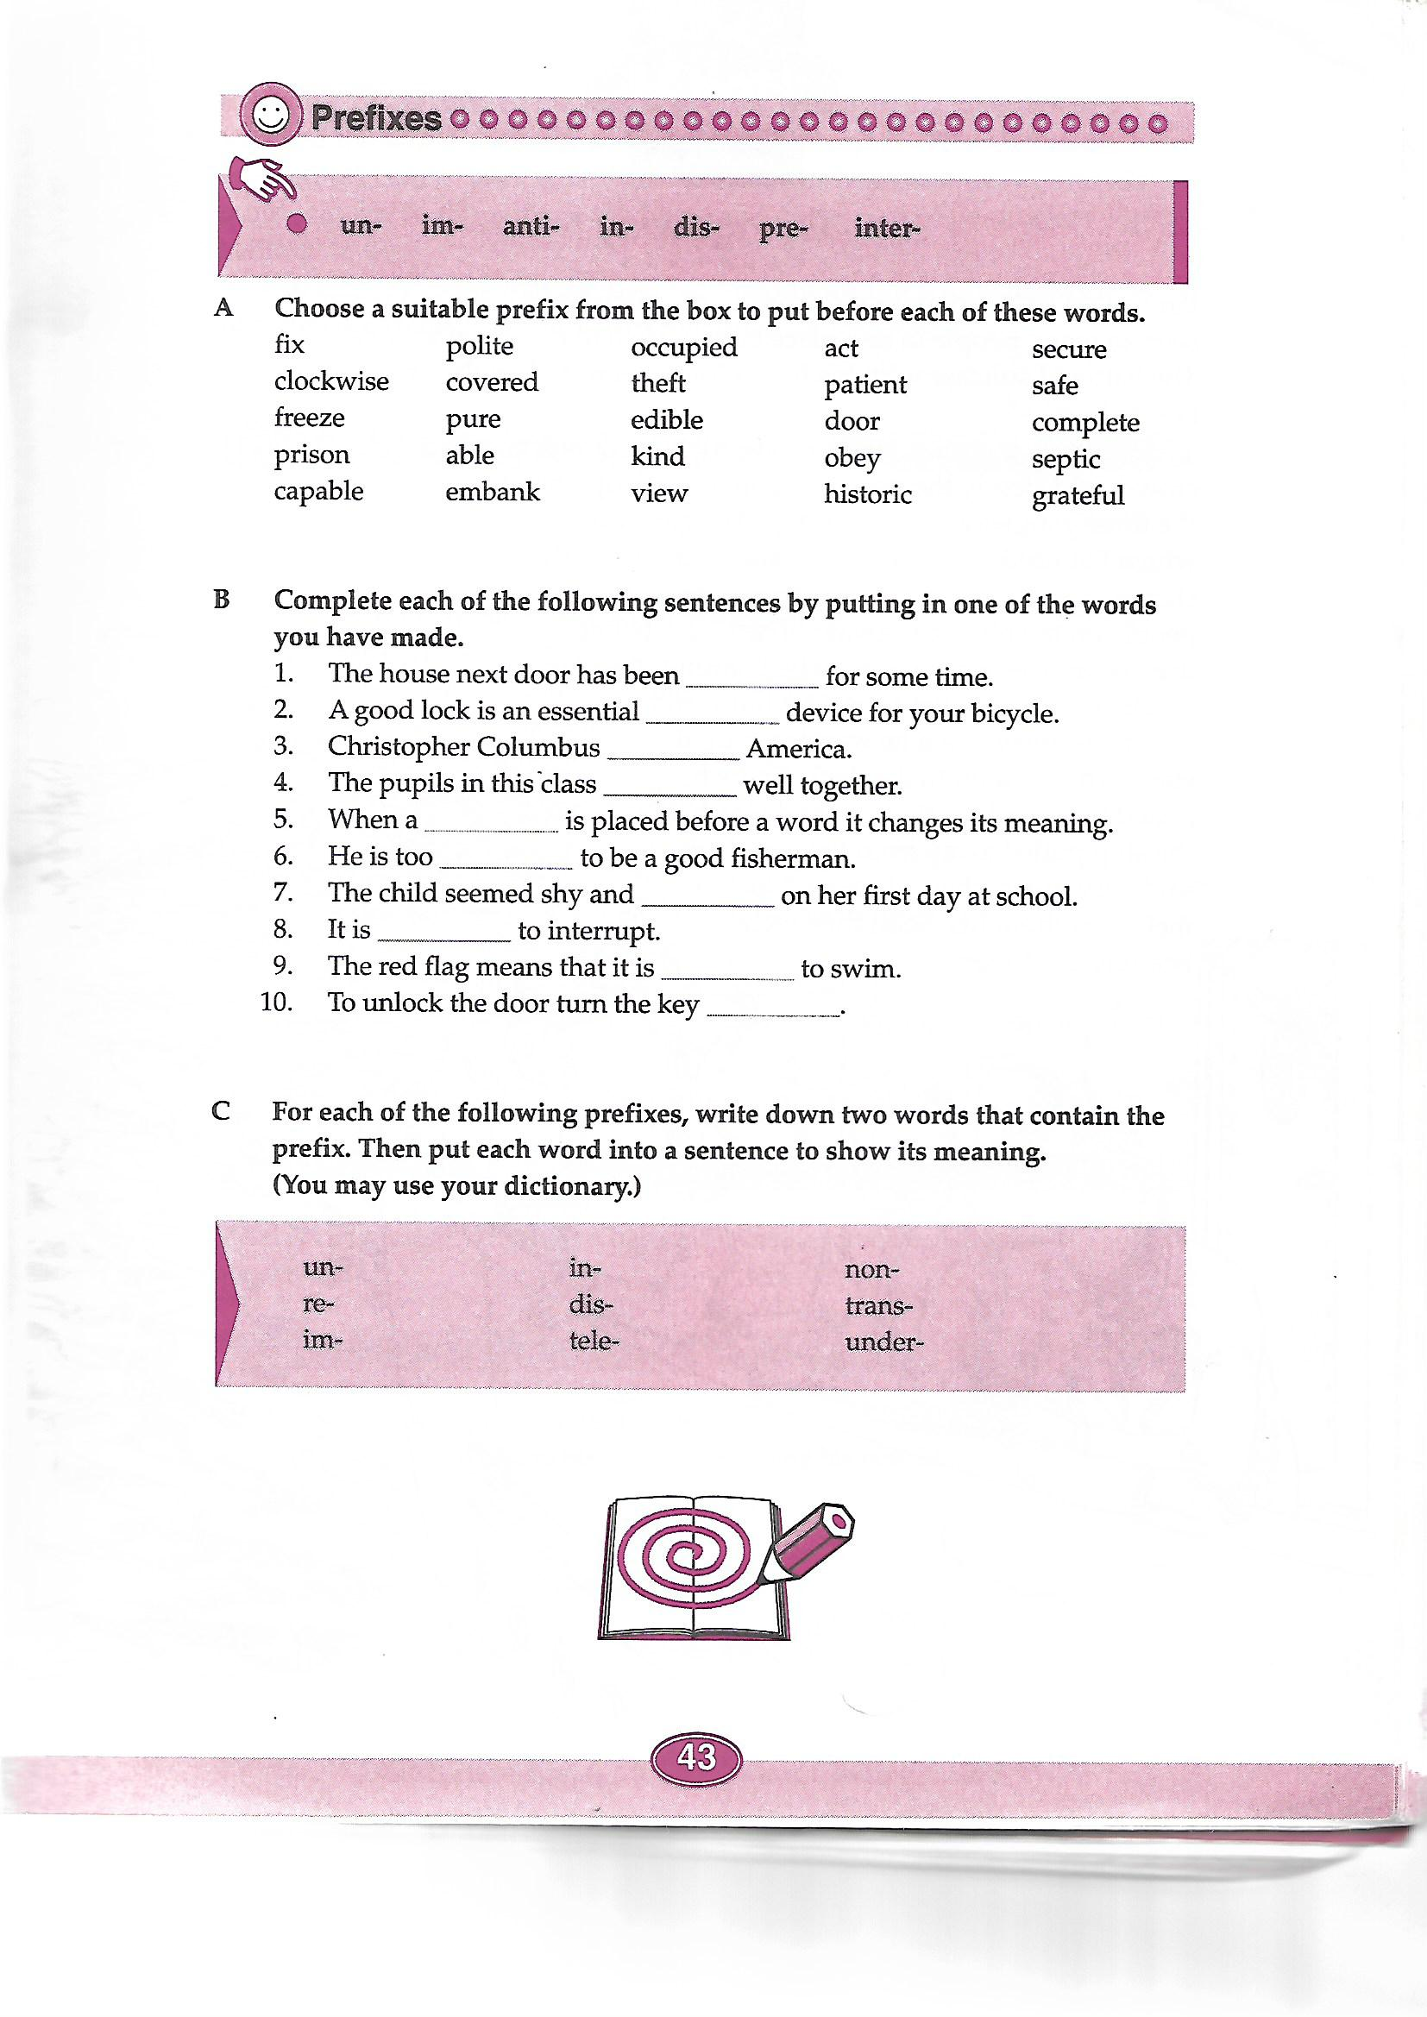
Thursday – Literacy P7

Tuesday P6 Time
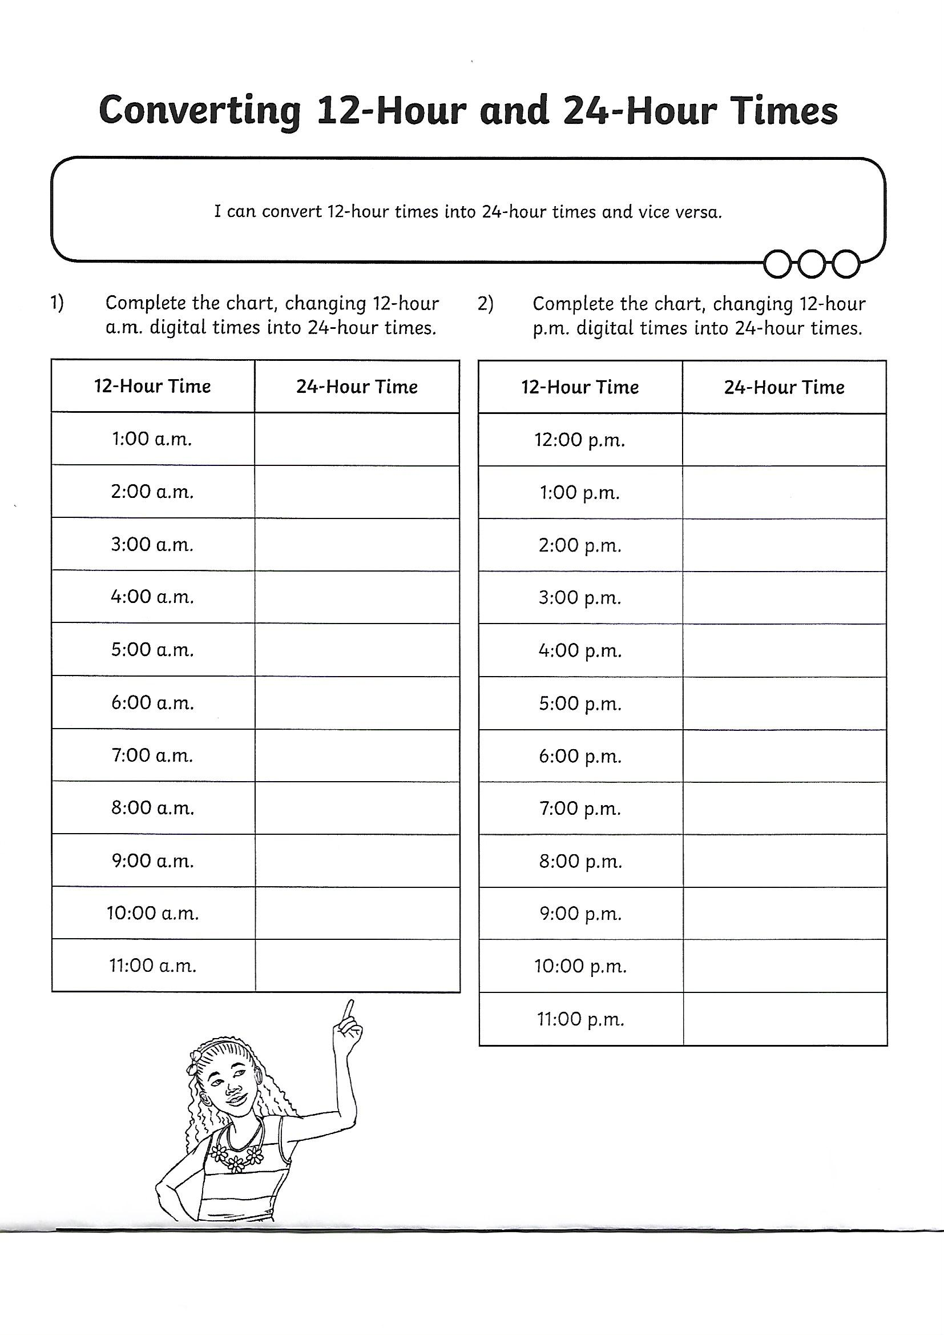

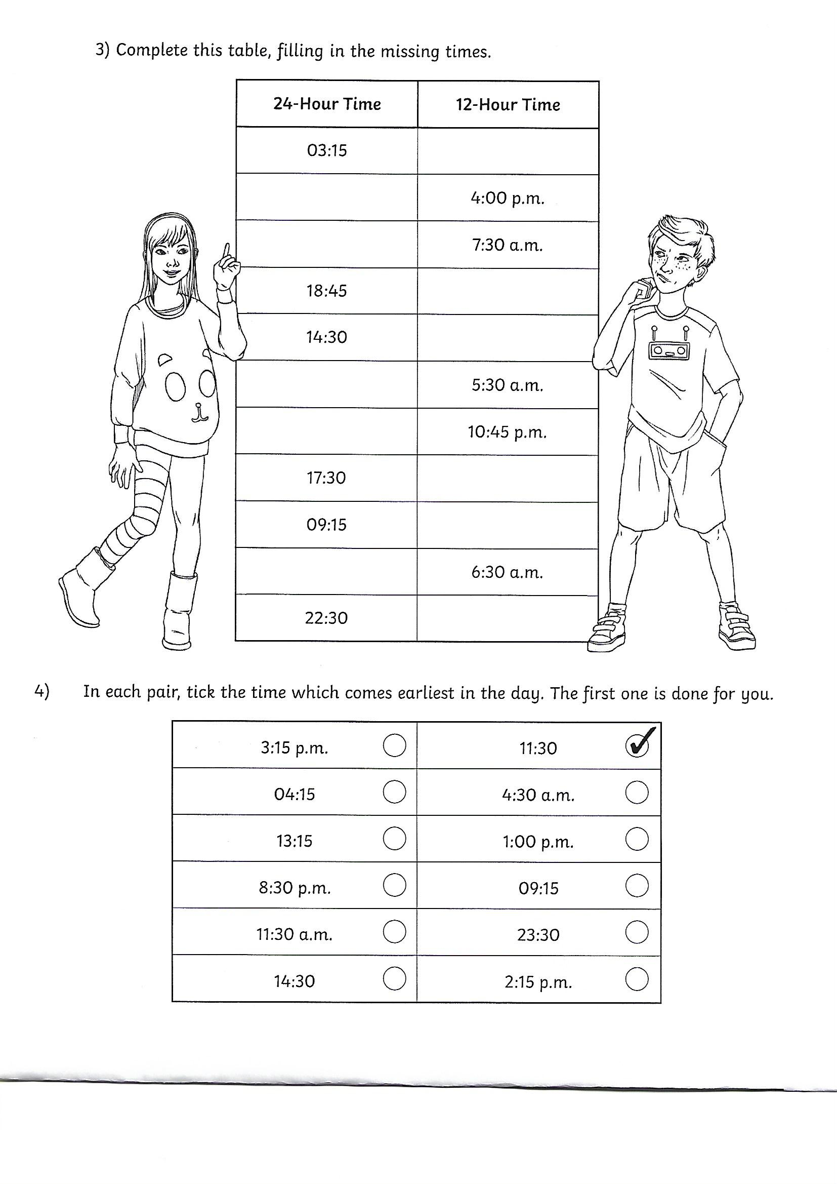

Tuesday P7 Time
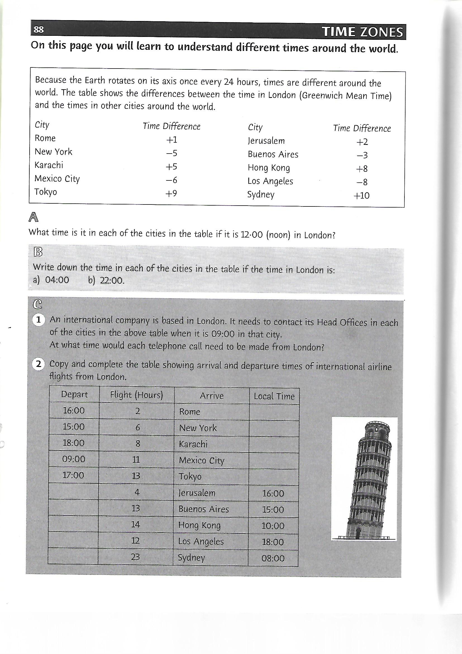
Numeracy Thursday Primary 6 – Data Handling

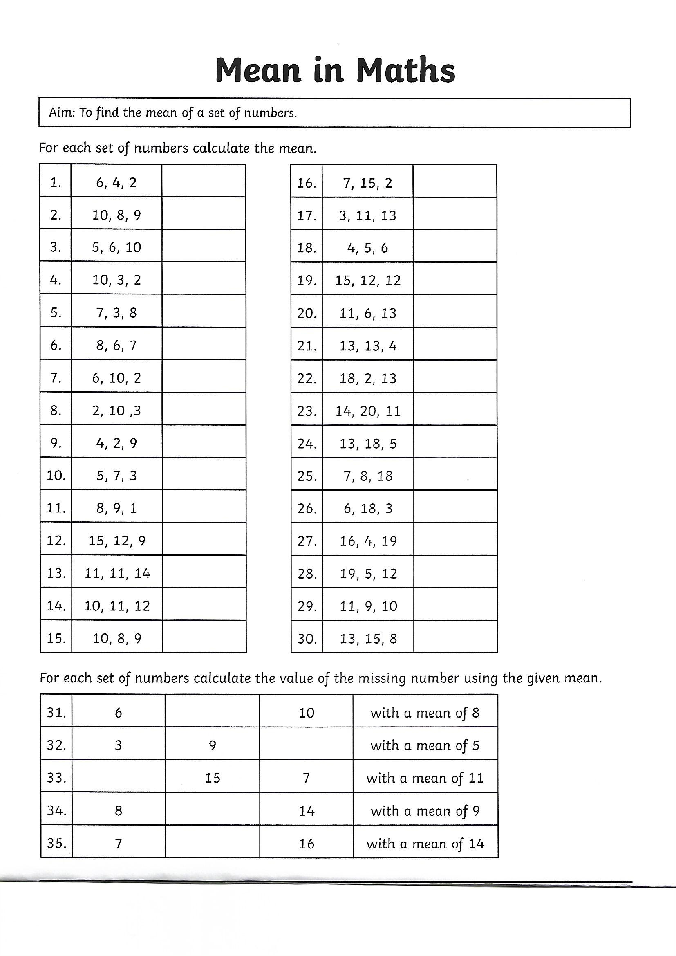
Numeracy Thursday Primary 7 – Data Handling

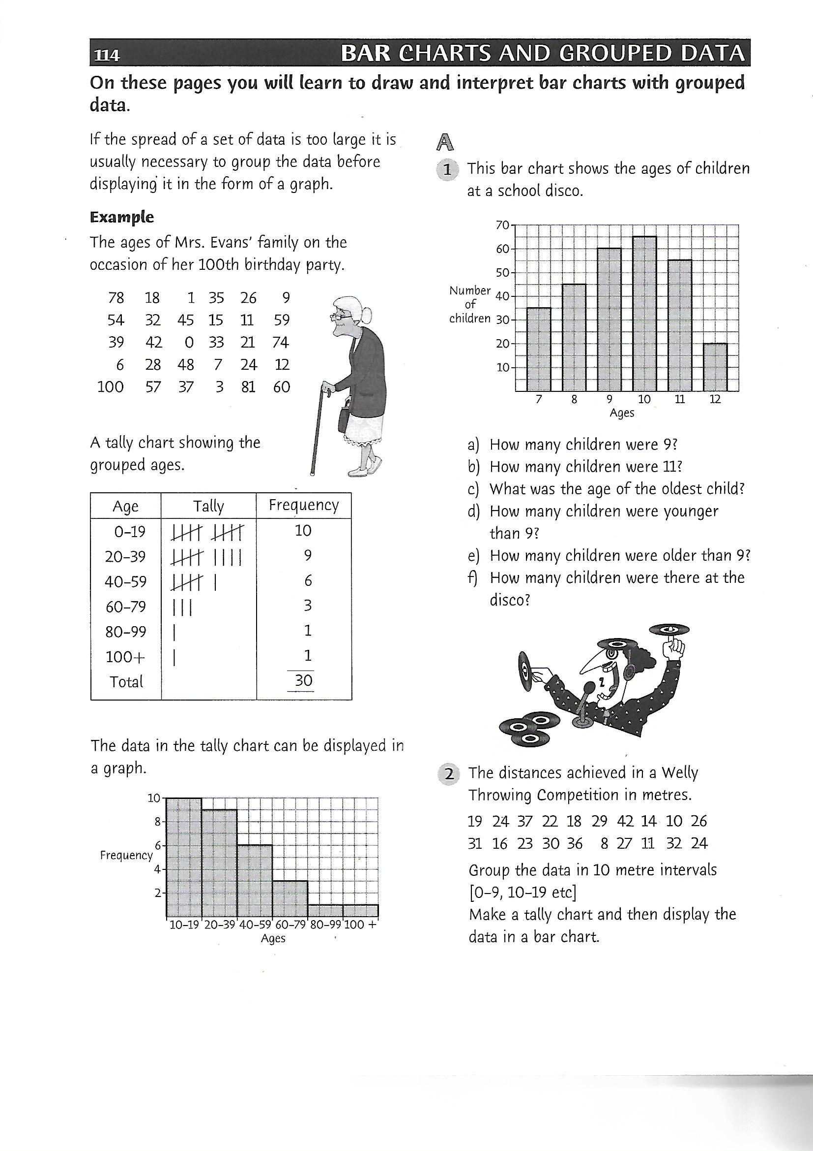
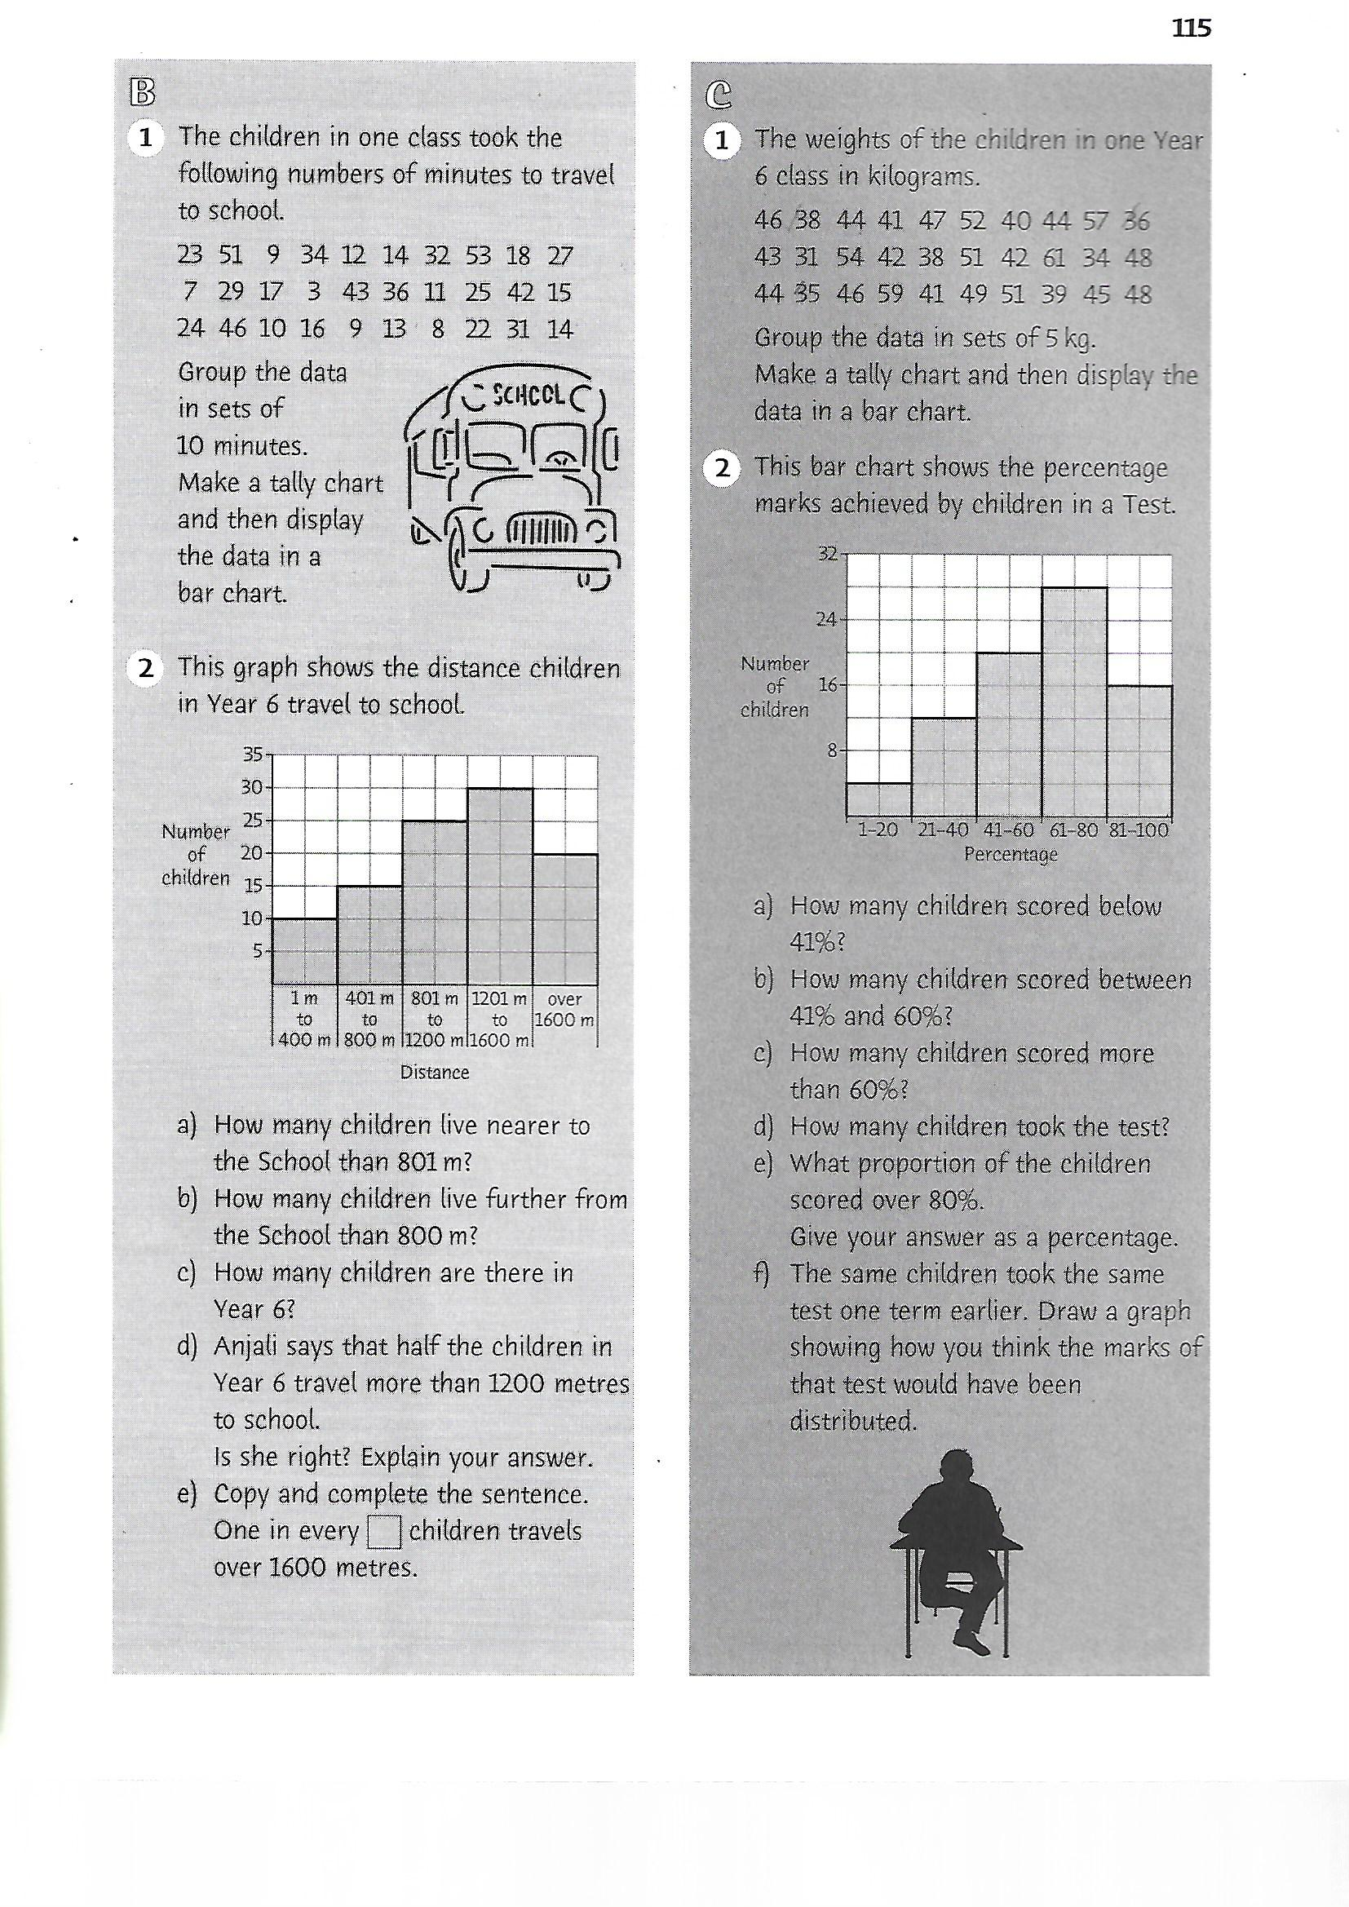

Numeracy Friday Primary 6
Most problem solving activities require modelling the activity to your child for the first two examples. Most children should be able to continue independently after this support.
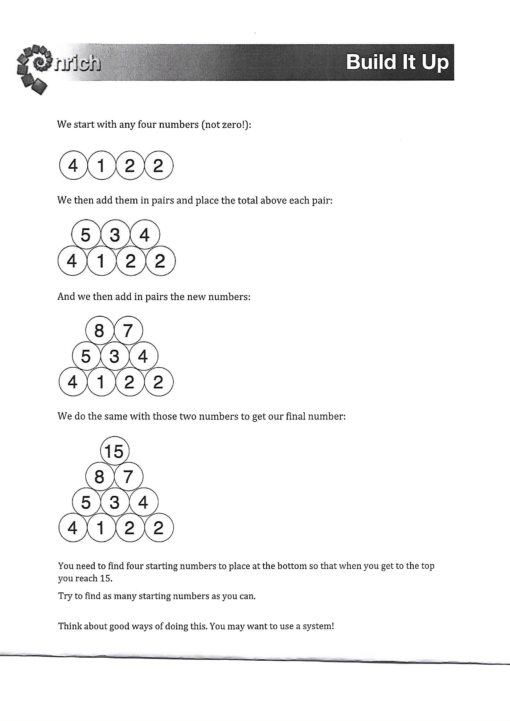
Primary 7 Friday – Problem Solving
Thirteen nations competed in a sports tournament. Unfortunately, we do not have the final medal table, but we have the following pieces of information:

1. Turkey and Mexico both finished above Italy and New Zealand.
2. Portugal finished above Venezuela, Mexico, Spain and Romania.
3. Romania finished below Algeria, Greece, Spain and Serbia.
4. Serbia finished above Turkey and Portugal, both of whom finished below Algeria and Russia.
5. Russia finished above France and Algeria.
6. Algeria finished below France but above Serbia and Spain.
7. Italy finished below Greece and Venezuela, but above New Zealand.
8. Venezuela finished above New Zealand but below Greece.
9. Greece finished below Turkey, who finished below France.
10. Portugal finished below Greece and France.
11. France finished above Serbia, who finished above Mexico.
12. Venezuela finished below Mexico, and New Zealand finished above Spain.

Can you recreate the medal table from this information

Stem Lesson – Tuesday

Lego Marble Maze examples;
See if you can create a maze from Lego. How adventurous will you be?? Have fun!

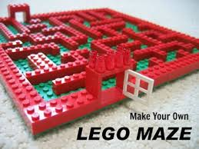
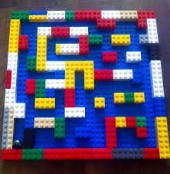

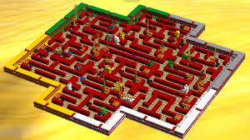

Paths Lesson - Thursday

I understand that this is a really challenging and uncertain time for you being stuck at home without the company of your peers, not being able to go to training, photography class or karate. However, it is also a challenging time for the adults who care for you at home. They are trying to home school you, perhaps a lot are also trying to work from home too, maybe some are out working, they are trying to entertain you, feed you, tidy up behind you and act as referee between the battles that you and your peers may be having. I want you to write a letter to an adult within your home and thank them for all that they are doing at present. I’ve always told you how important those two words are! Remember to say ‘Thank You,’ it will mean so much!!

