Dear Parents,
Please find attached your child’s schedule for Week 3. All activities listed can be extended using the online activities already provided. Again, please ensure children follow the online safety guidelines and exercise caution when using electronic devices. At the time of writing this all websites/ apps are free registration however that can change on a daily basis. Children need a good balance of worksheet activities and online activities. Don’t forget to stress the importance of good letter and number formation during completion of activities.
Reading Material
Please continue to ensure that your children read for 30 minutes each day. If they have run out of reading material find listed some excellent websites that are currently free to allow your child to access eBooks.
Renaissance at Home: readon.myon.co.uk
Libraries NI: librariesni.org.uk – sign up for free
Oxford Owls: https://www.oxfordowl.co.uk/for-home/find-a-book/library-page/
Harry Potter Fans
I know there are a lot of J.K. Rowling fans within the classroom. She has kindly launched harrypotterathome.com to help spread a little bit of magic. It’s full of quizzes and activities to keep the children busy
RTE to broadcast ‘School on TV’ from Monday
I have been watching this with my own daughter every morning and there is some excellent material on it. It also helps to reinforce previous learning for the older children. This will run from 11 a.m. – 12 p.m. Monday to Friday on RTE 2. Supporting worksheets and other material will be on RTE.ie/learn. Some content may be delivered in Irish.
Learn Irish
https://tyronegaa.ie
Thanks to Tyrone GAA for granting access to this website and resources, it will be particularly useful for our Primary 7 children who will be transferring to Post Primary in September to allow you to build up a good foundation within the Irish language. Click on the tab: Learn Irish! and select KS1&KS2. Work your way through these lessons.
Numeracy Support
- Football fans will be delighted to learn that the Premier League have developed Maths activities and Problem solving activities on their website Premier League Primary Stars: plprimarystars.com
- If you are having difficulty explaining any mathematical concepts to your children this week Carol Vorderman is doing online maths tutorials www.themathsfactor.com
- Education City is now up and running.
Minecraft
Minecraft have FREE digital lessons for the children to enjoy at home until 30th June these can be found in Minecraft Marketplace: Minecraft.net – www.minecraft.net/en-us/marketplace/education

Pupil Wellbeing
- The Education Authority’s Autism Service have developed ASD resource packs for pupils on their webpage. They can be accessed via the link http://www.eani.org.uk/services/pupil-support-services/autism-advisory-intervention-service-aais
- The Southern Trust have also complied a range of resources and helpful advice to help keep stress to a minimum during these times. It can be accessed through southerntrust.hscni.net/Autism.htm – this has been recommended by the Education and Training Inspectorate.
- Healthy Kidz Global Challenge – free access to mini workouts, games, beat the coach challenges and mindfulness tips.
- I hope you have been able to access the Wellread App supplied free to us from the Verbal Arts Centre, it has some excellent material.
- Relax Kids have a lovely pack full of great ideas and resources for free download http://www.relaxkids.com/calm-pack.
- Autism NI have created a social story to help children understand self- isolation and why it is important to keep everyone safe. www.autismni.org/why-do-i-have-to-stay-at-home.html The language within this booklet is perfectly pitched towards children of all ages and abilities.
- Autism NI have also created a fantastic ‘Anxiety Resource Pack,’ which can be downloaded from www.autismni.org/anxiety-resource-pack.html
- A list of free Apps that parents can download for their children to manage their self-care and emotional well-being : www.autismni.org/free-apps-for-children---self-care-and-emotional-well-being.html
Please remember that this is only a guide. Every household has different demands at the moment, do as much or as little as you please. There are a lot of life skills that are developed elsewhere around the home and outdoors, skills that worksheets don’t develop and that are as equally important.
Take Care and pass on our best wishes to the children and most importantly have a lovely yet unique Easter!
Miss Devine and Miss McCauley

Spelling Lists for Week 3
Topic Spellings therefore no variations – Year 6 and 7 are the same.
Spelling List

Jesus
Jerusalem
Procession
Disciples
Triumphant
Hosanna
Condemn
Crucifix
Crucifixion
Stations
Crown
Thorns
Temple
Judas
Easter
Tomb
Temple
Cockerel

 | Monday | Tuesday | Wednesday | Thursday | Friday
9-15 -9-30 | Phonics  Palm Sunday Word Search- see attached | Phonics  Stations of the Cross Word Search – See attached | Phonics  The Easter Story Word Search – See attached | Phonics  Create an acrostic poem using the words EASTER STORY. Incorporate as many of your spelling words into this poem as possible. | Phonics  Spelling Test
9-30-9-45 | Mental Maths  Complete Mental Arithmetic Book Section A/B or C or Mental Maths Daily test | Mental Maths  cgpbooks.co.uk  Test 3  11+ Online 10 Minute Tests - Maths | Mental Maths  Complete Mental Arithmetic Book Section A/B or C or Mental Maths Daily test | Mental Maths  Top Marks Daily 10  Select Level 5 P6  Level 6 P7 Select Multiplication – Mixed tables | Mental Maths  Complete Mental Arithmetic Book Section A/B or C or Mental Maths Daily test
9-45-10.30 | Religion  Read KS2 The Easter Story PowerPoint accessed from Twinkl  www.twinkl.ie/resource/ks2-the-easter-story-powerpoint-t2-or-569 | STEM - Minecraft Lesson – The Human Eye – see details above on how to access. | Religion  Complete Easter Story comic strip – see attached page | PATHS  Do one thing from the 30 Days of SEL Poster – see attached.  I hope that someone at home appreciated their letter last week. | PE – With supervision from parents try Annie Deery’s yoga class for kids. She can be found on facebook – Annie Deery.
Break
11.00 -11.45 | Literacy  Complete one of your comprehension activities found within your pack. | Literacy  Reading Newsdesk tasks  See attached notes | Literacy  Procedure Writing  See notes attached | Literacy – T/L  Take part in some Home Economics with adult supervision and make something; a sandwich, pancakes, perhaps even a cheese cake. | Literacy  Procedure Writing  See notes attached
11.45-12.00 | Movement Break  GoNoddle  https://family.gonoodle.com | Movement Break | Movement Break | Movement Break | Movement Break
12.00 – 12.45 | Numeracy  Number – See Attached | Numeracy  Measures –  P6 Time  P7 Time  See attached | Numeracy  P6 – Time Mathletics Booklets downloaded last week  P7 pgs 41+42 | Numeracy  P6 - Data Handling See Attached  P7 – Problem Solving  See attached | Numeracy  P6 – Problem Solving See attached  P7 – Problem Solving  See attached
Lunch
1.30-2.30 | WAU –  Salmon Ambassadors worksheets | Art  Create an Easter Card – See attached page for ideas | PE –PE with Joe Wicks – Youtube – try one of his classes | WAU –  Salmon Ambassadors worksheets | Golden Time  Or why not do some jobs around the house to help out ??
2.30 – 3.00 | Accelerated Reading | Accelerated Reading | Accelerated Reading | Accelerated Reading | Accelerated Reading

Monday- Phonics
Primary 6 and 7

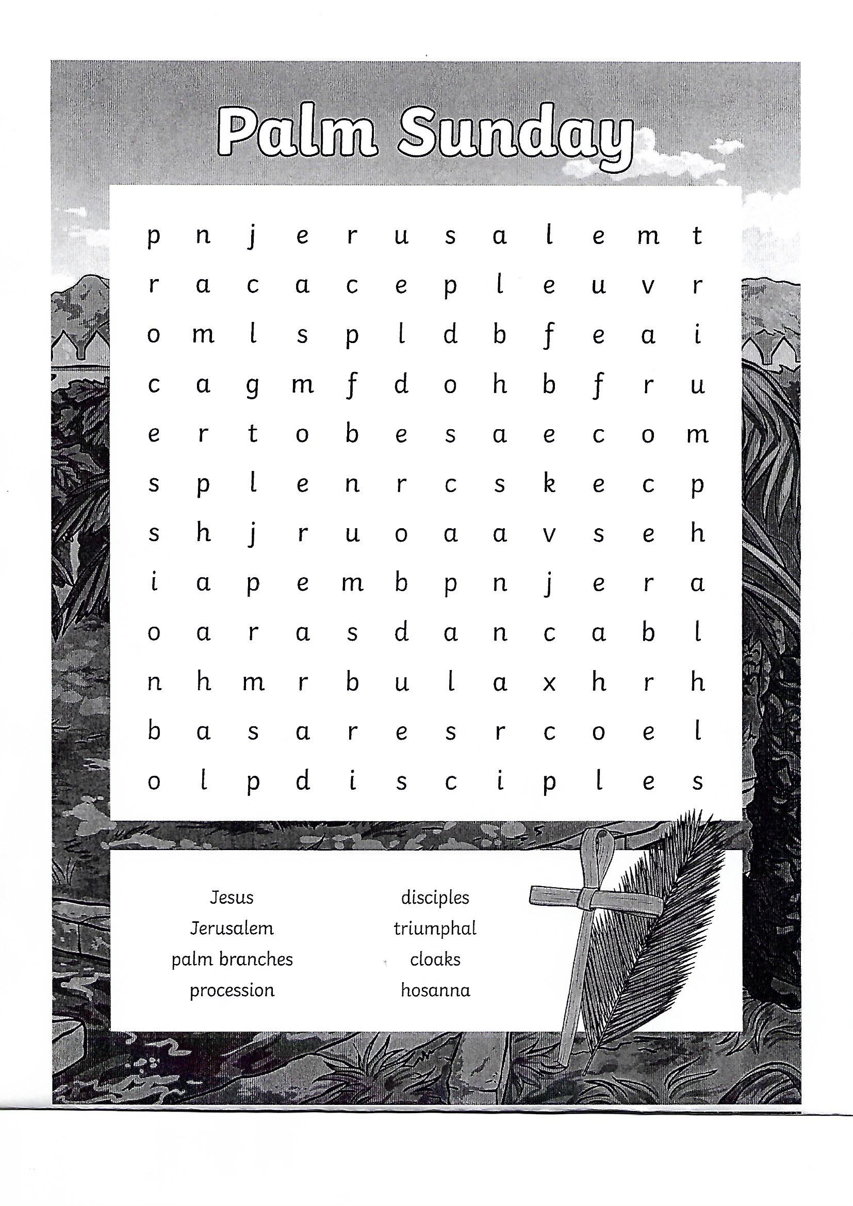
Tuesday- Phonics
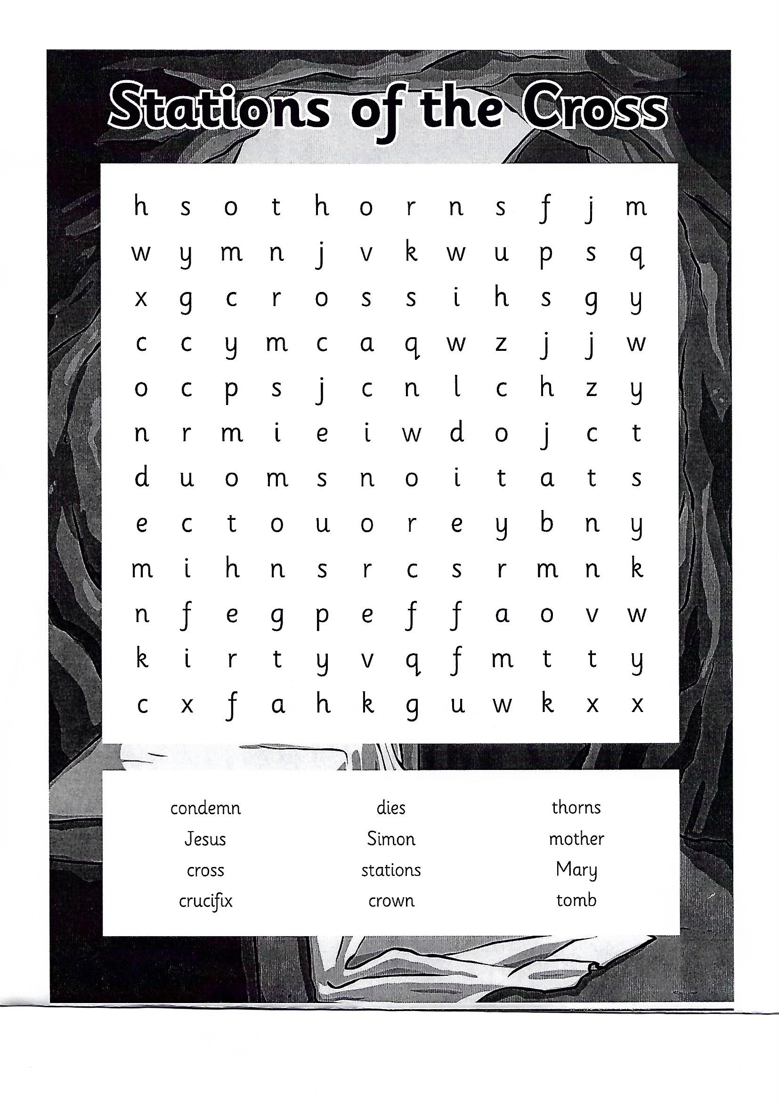
Primary 6 and 7
Wednesday- Phonics
Primary 6 and 7
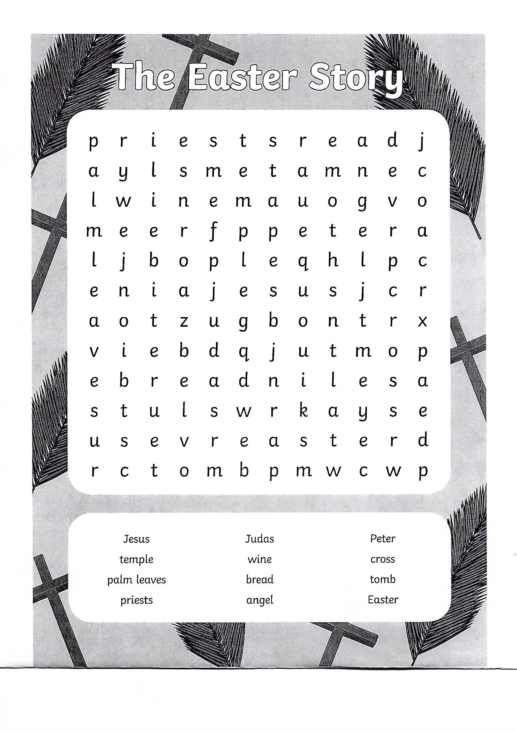
Thursday- Phonics
Primary 6 and 7

E _____________________________________________________________
A _____________________________________________________________
S _____________________________________________________________
T _____________________________________________________________
E _____________________________________________________________
R _____________________________________________________________

S _____________________________________________________________
T _____________________________________________________________
O _____________________________________________________________
R _____________________________________________________________
Y _____________________________________________________________

Tuesday - Literacy for Primary 6 and 7 _ Newsdesk Task
Enter www.c2kschools.net and then enter C2k username and password. Any difficulties with this please contact Rosemary.
Click onto the Newsdesk, then Fact Files.
Read the fact files called ‘Reduce, Reuse and Recycle’ and ‘Water’. I want you to leave a comment about each news story so that myself and your peers can read your opinion on the news story.

Wednesday - Literacy for Primary 6 and 7
Highlight and label the features of Procedure Writing in both examples.
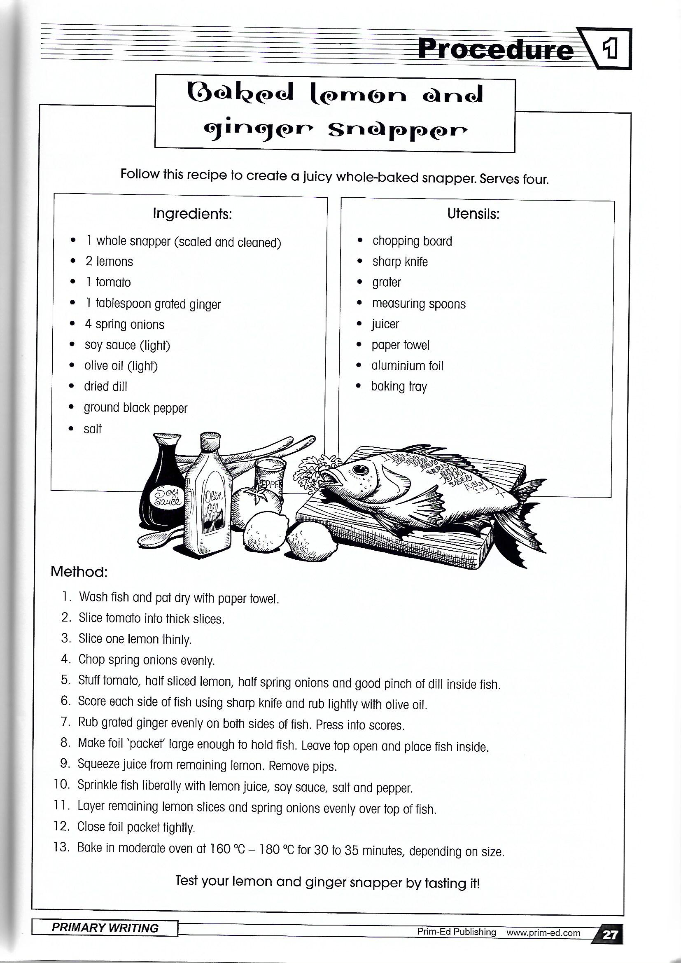
Features: Title, Goal- purpose of the procedure, Materials – materials required to complete the procedure, Method/Commands – numbered steps, each step beginning with an imperative (bossy) verb, an evaluation and an illustration.

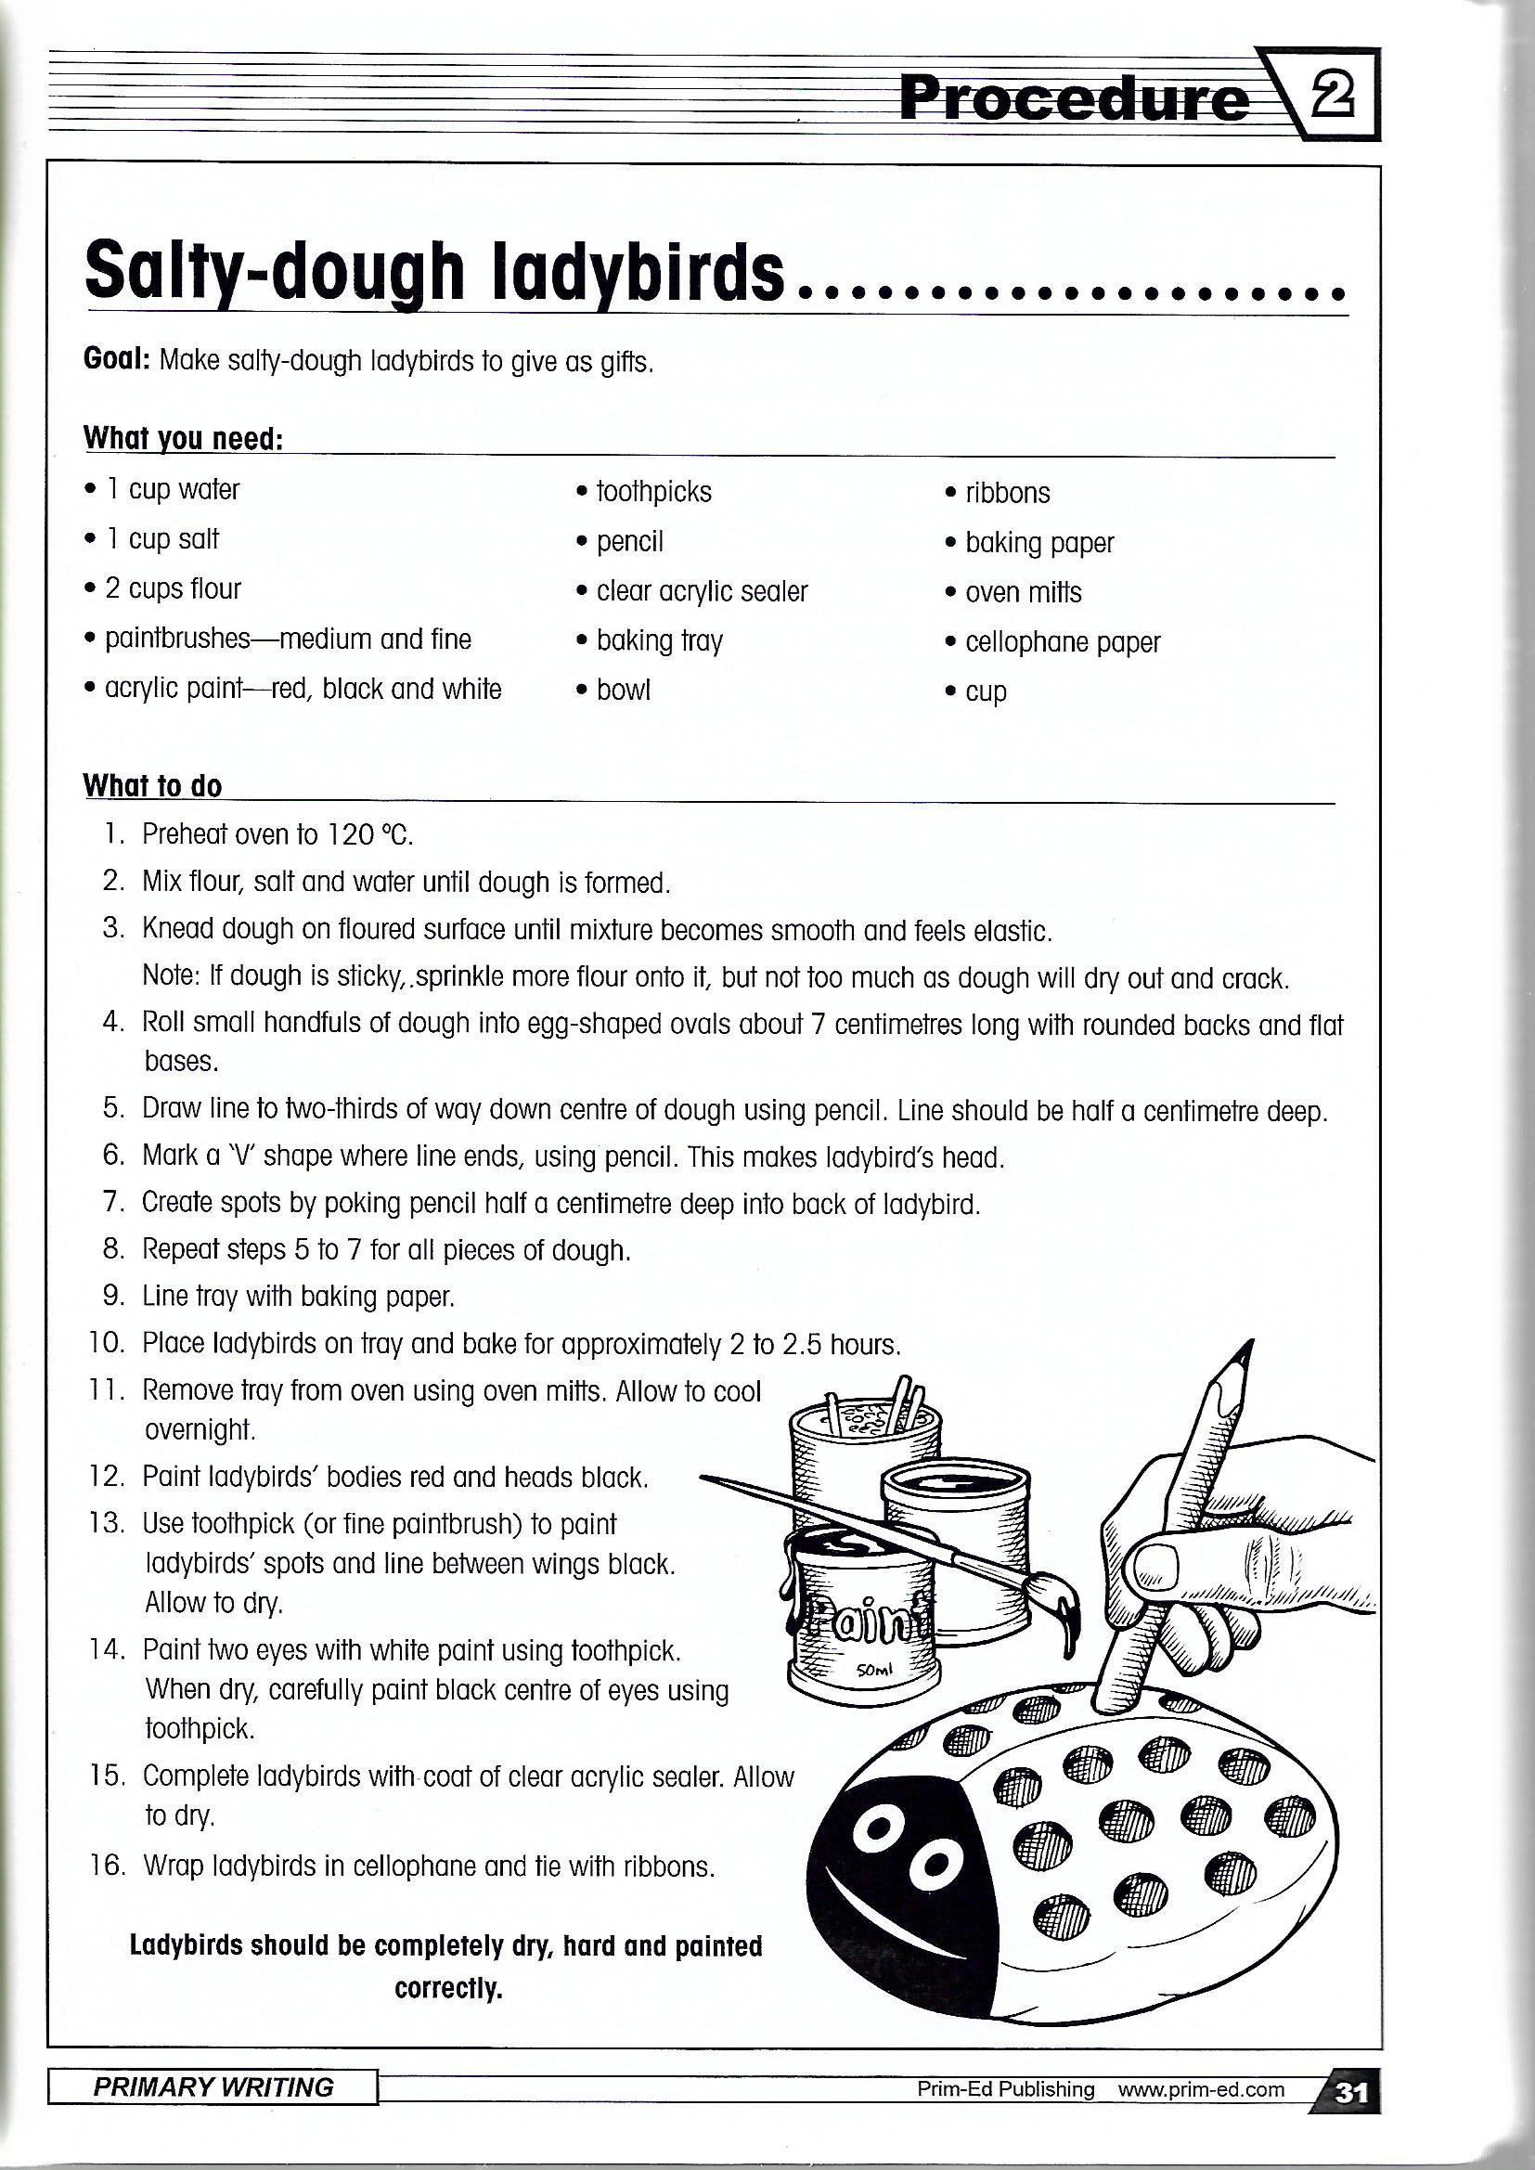

Friday - Literacy for Primary 6 and 7
Create a procedure for something that you made yesterday. Don’t forget to include all the features in your writing that you highlighted on Wednesday.

Easter Card Ideas

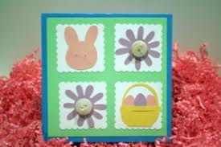
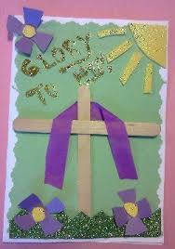

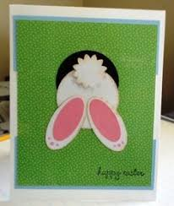

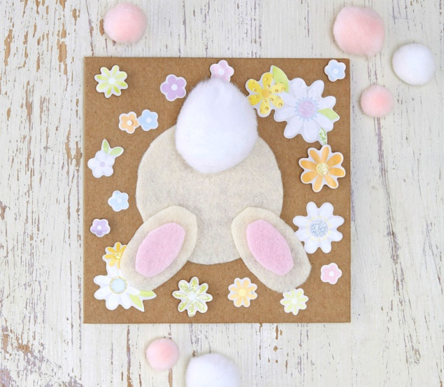

Monday – Number P6
Complete Times tables speed test on www.timestables.co.uk and then complete the following Easter themed numeracy sheet
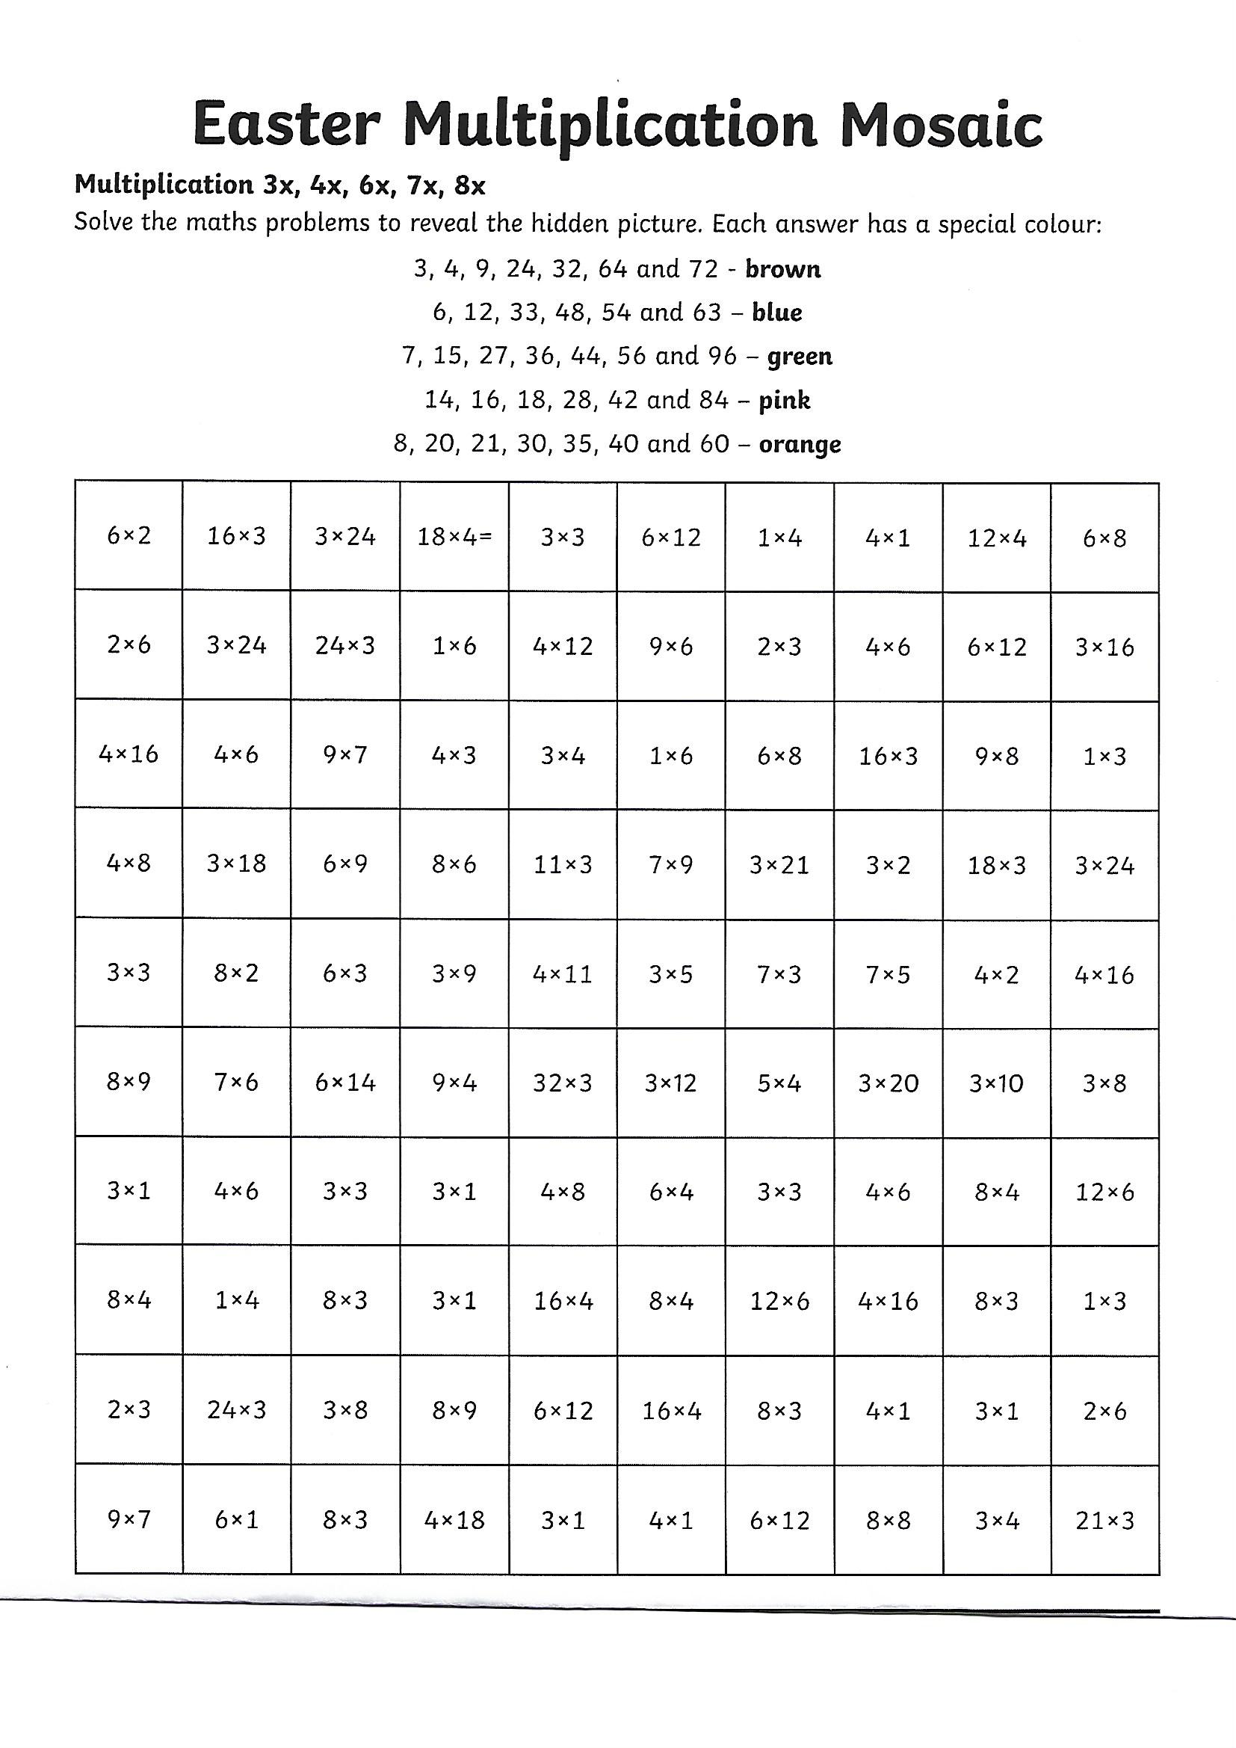

Monday – Number P7
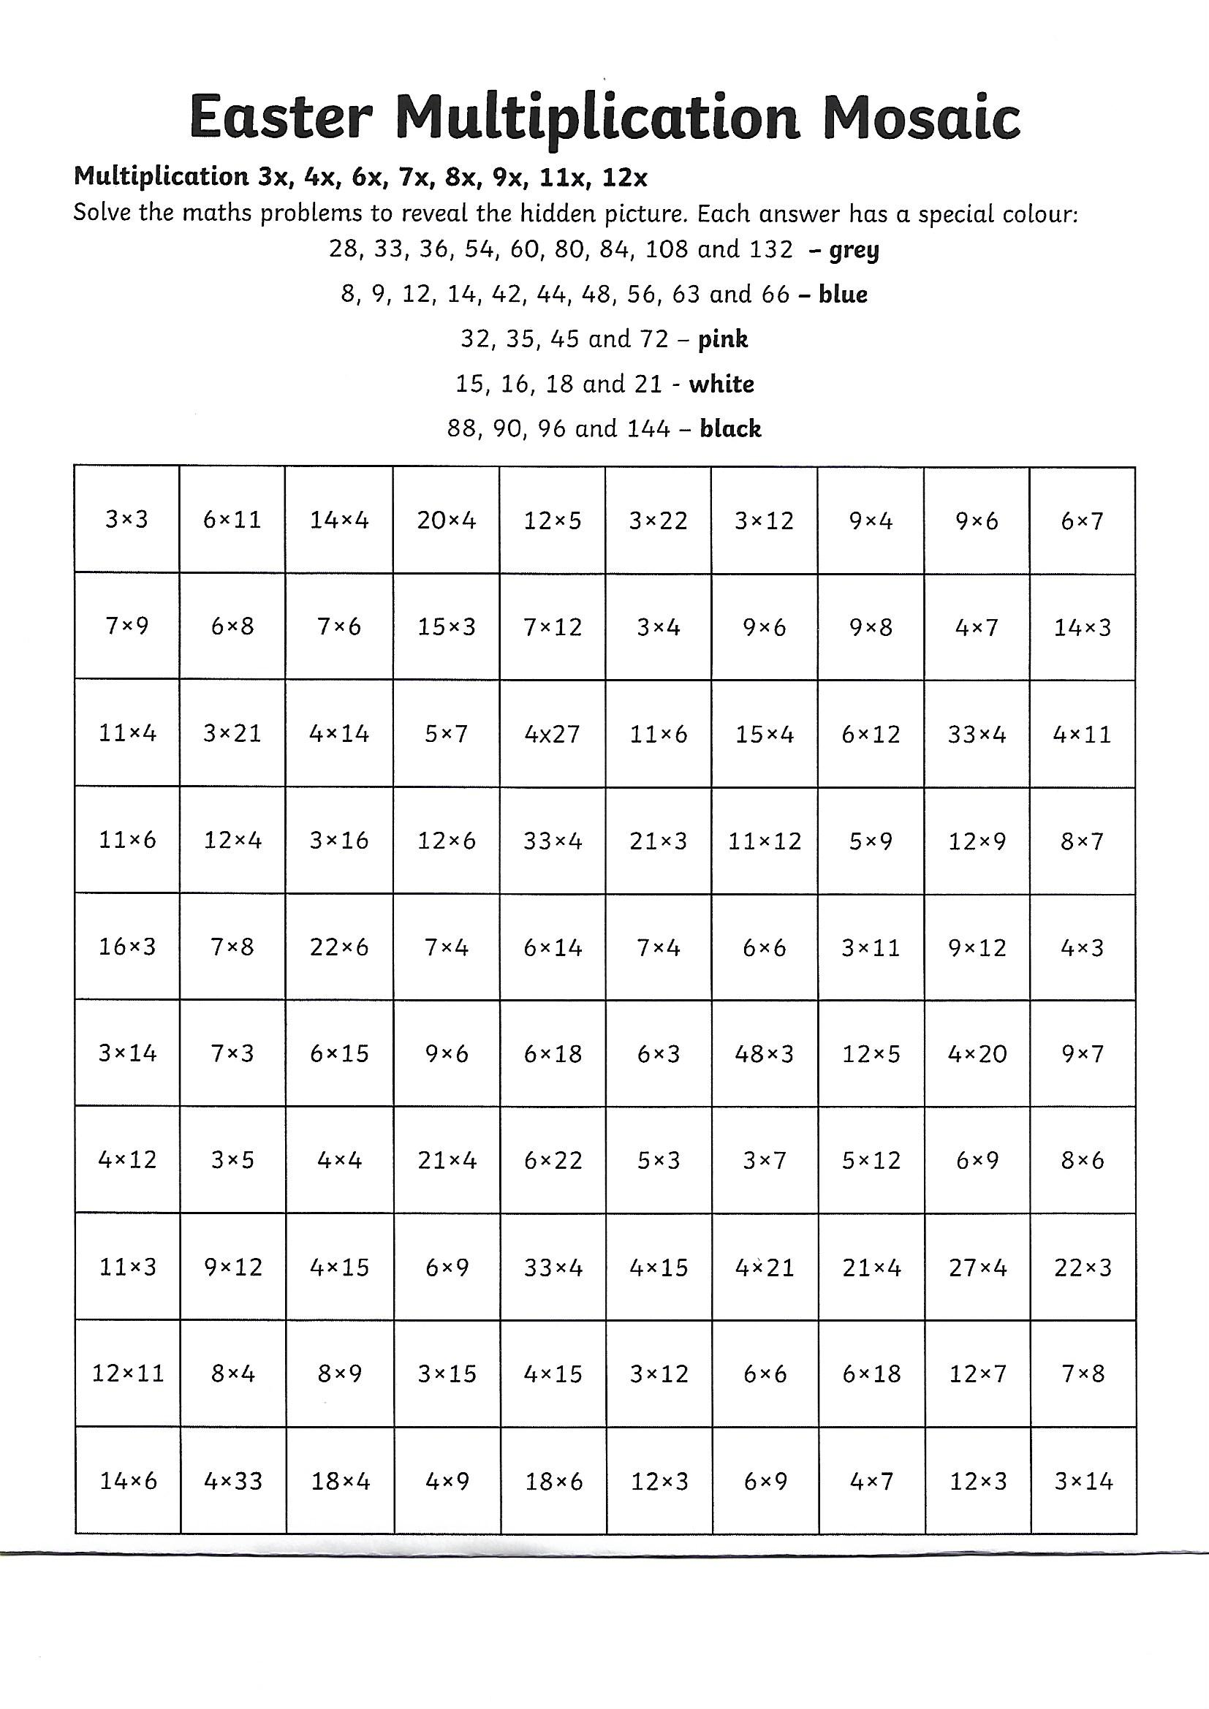
Times tables speed test on www.timestables.co.uk and then complete the following Easter themed numeracy sheet.

Tuesday P6 Time
Go onto YouTube and search for Stuart Montgomery. He has An excellent tutorial on the 24hour clock. It starts with revision but gets progressively harder.
It is called Remote Learning – Numeracy 24 hour clock
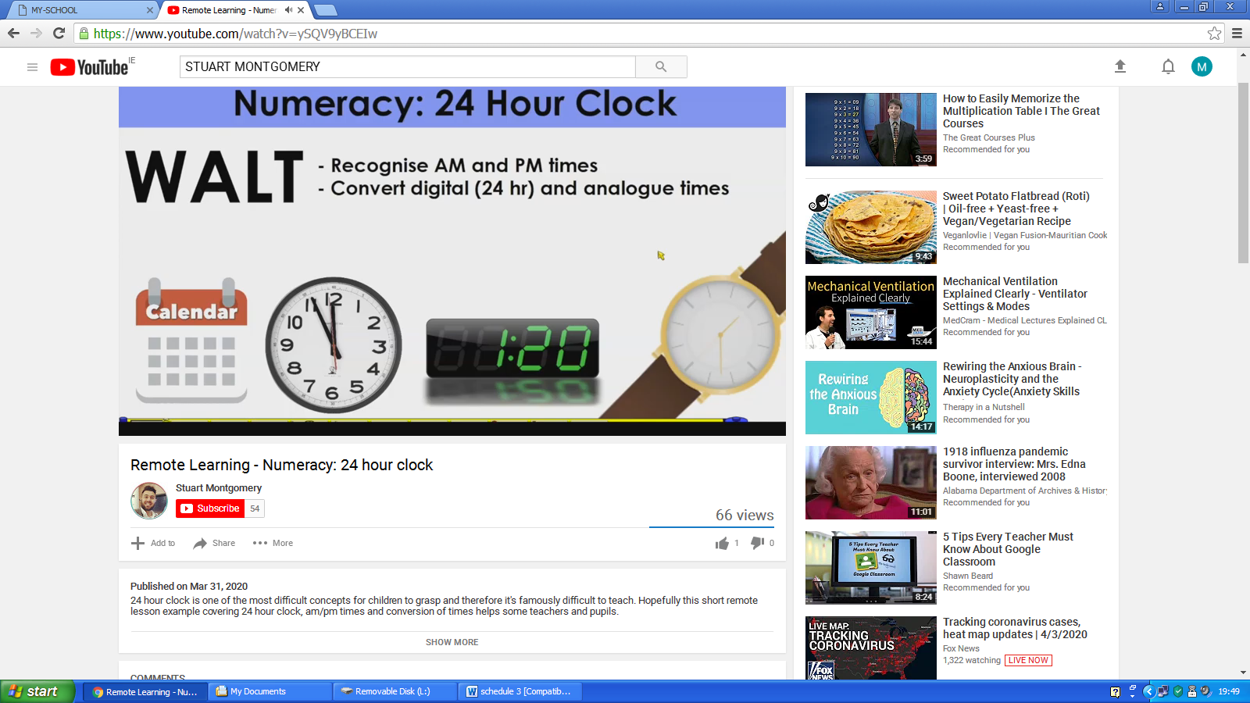

Tuesday Time P7

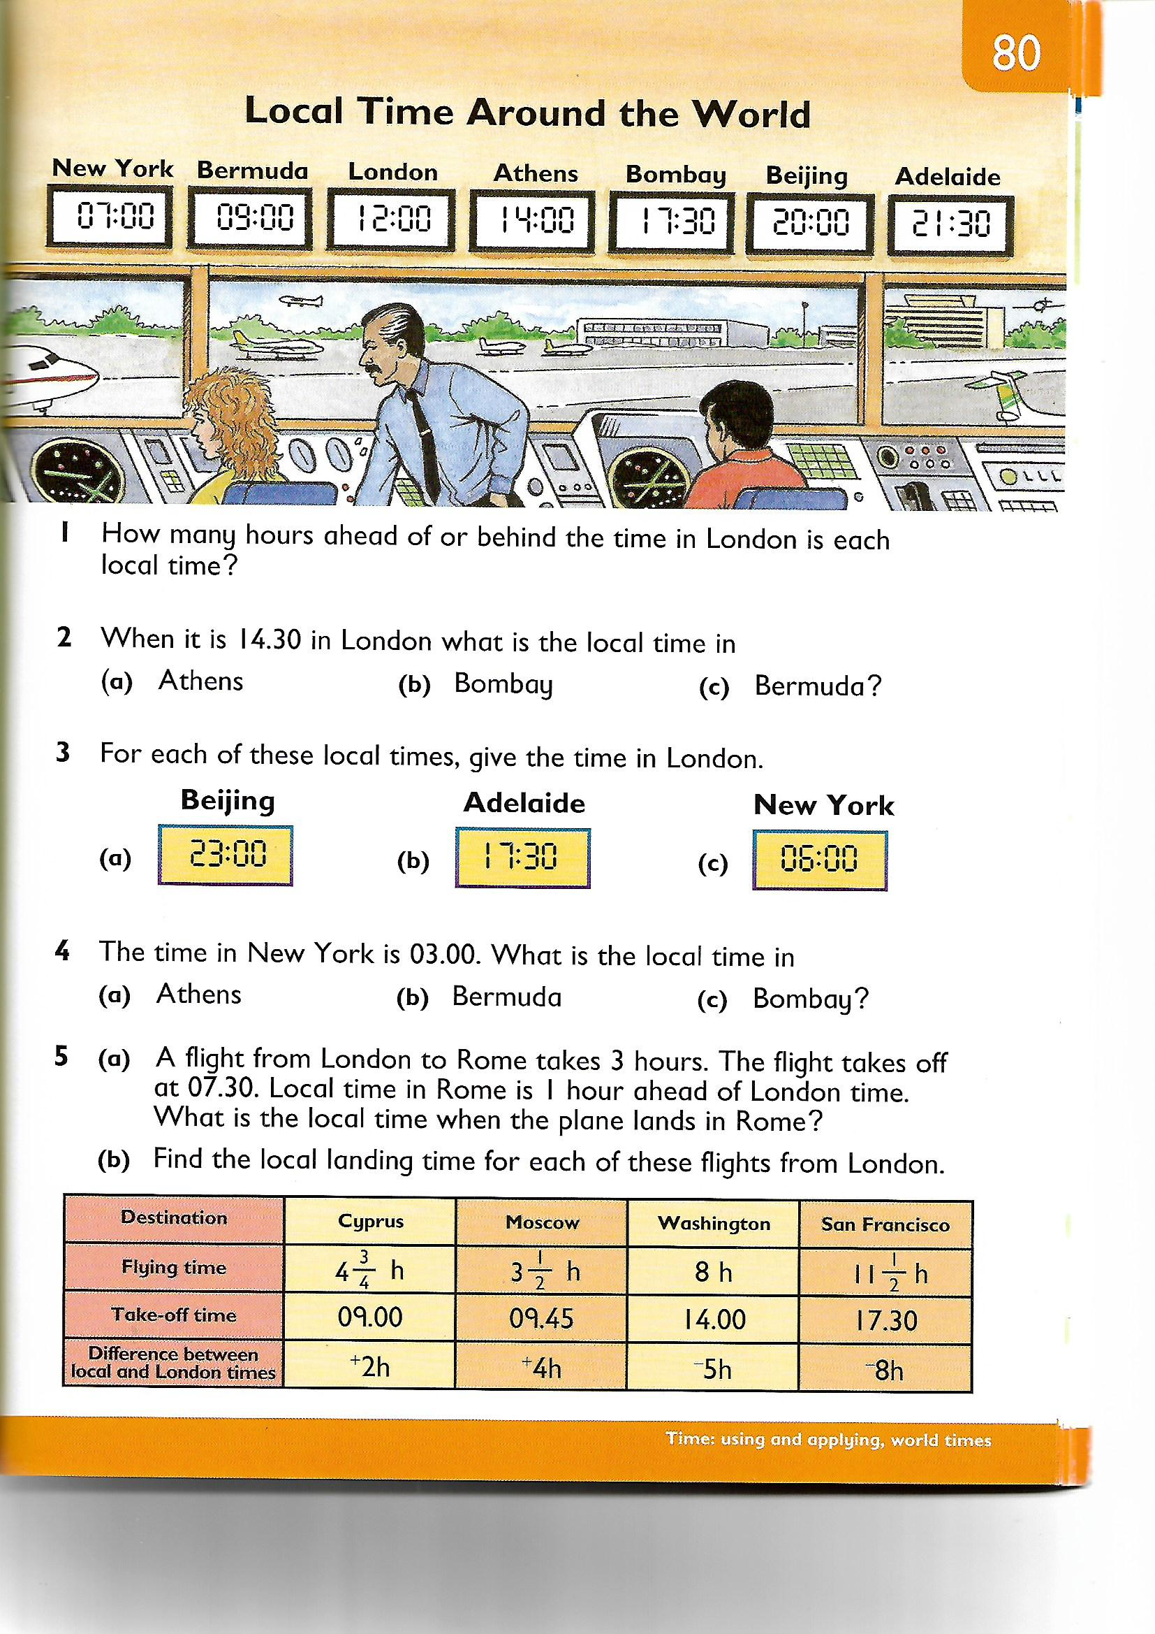
Wednesday Time P6
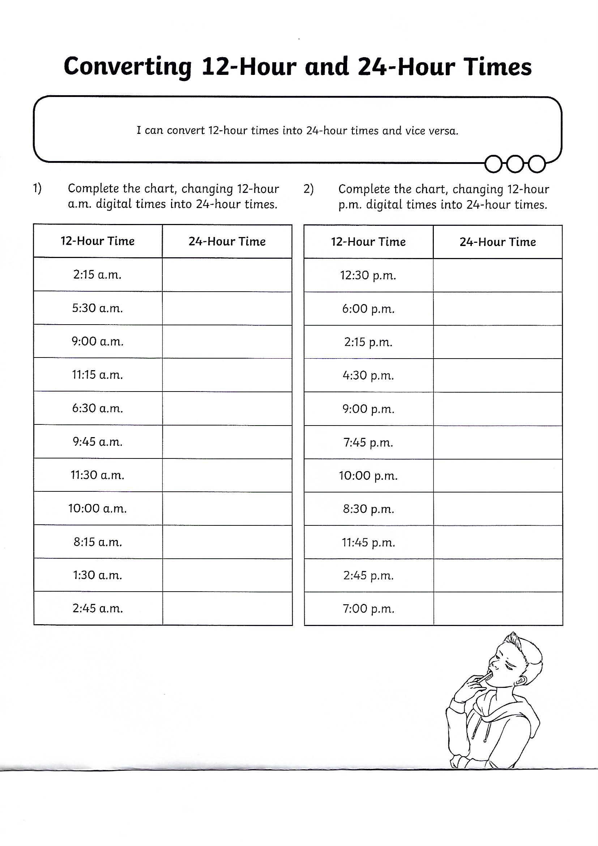

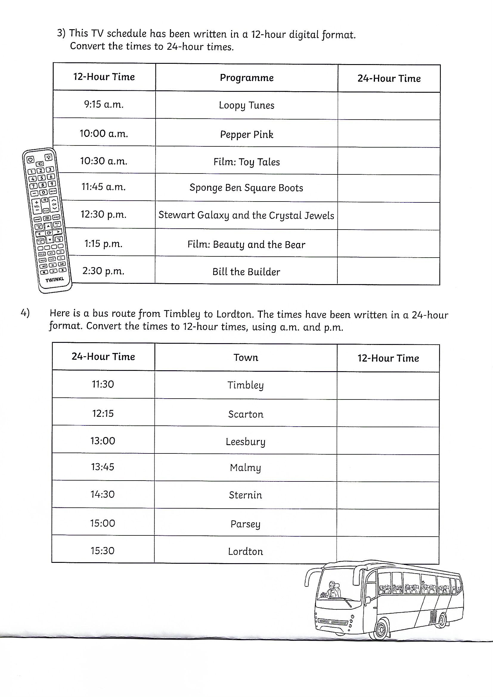

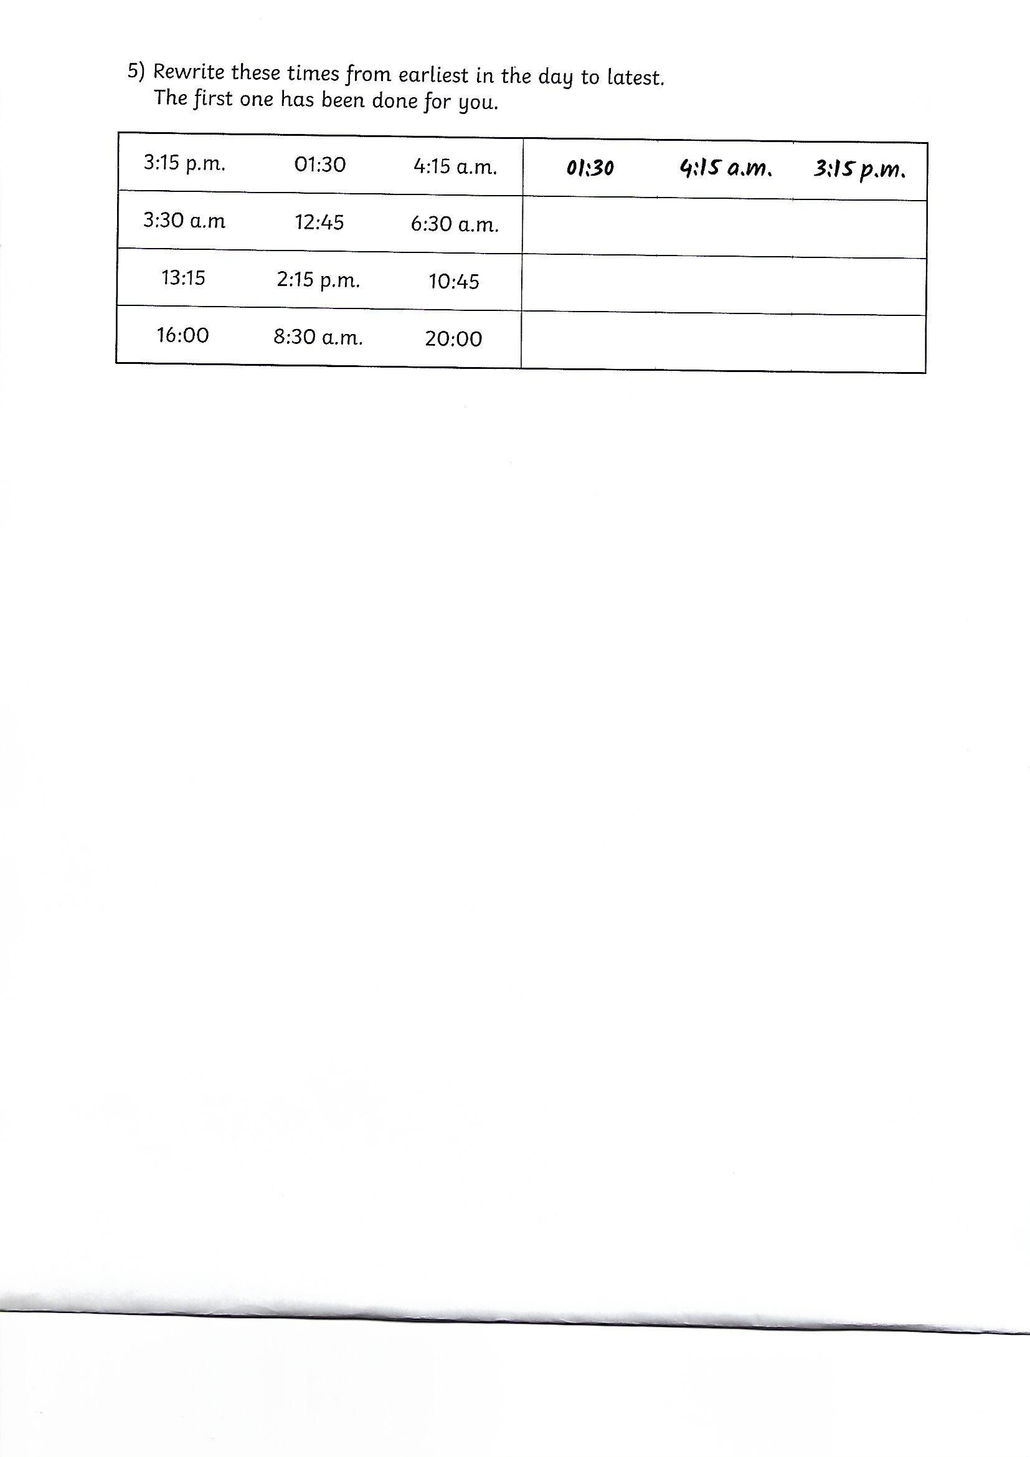

Numeracy Thursday Primary 6 – Data Handling
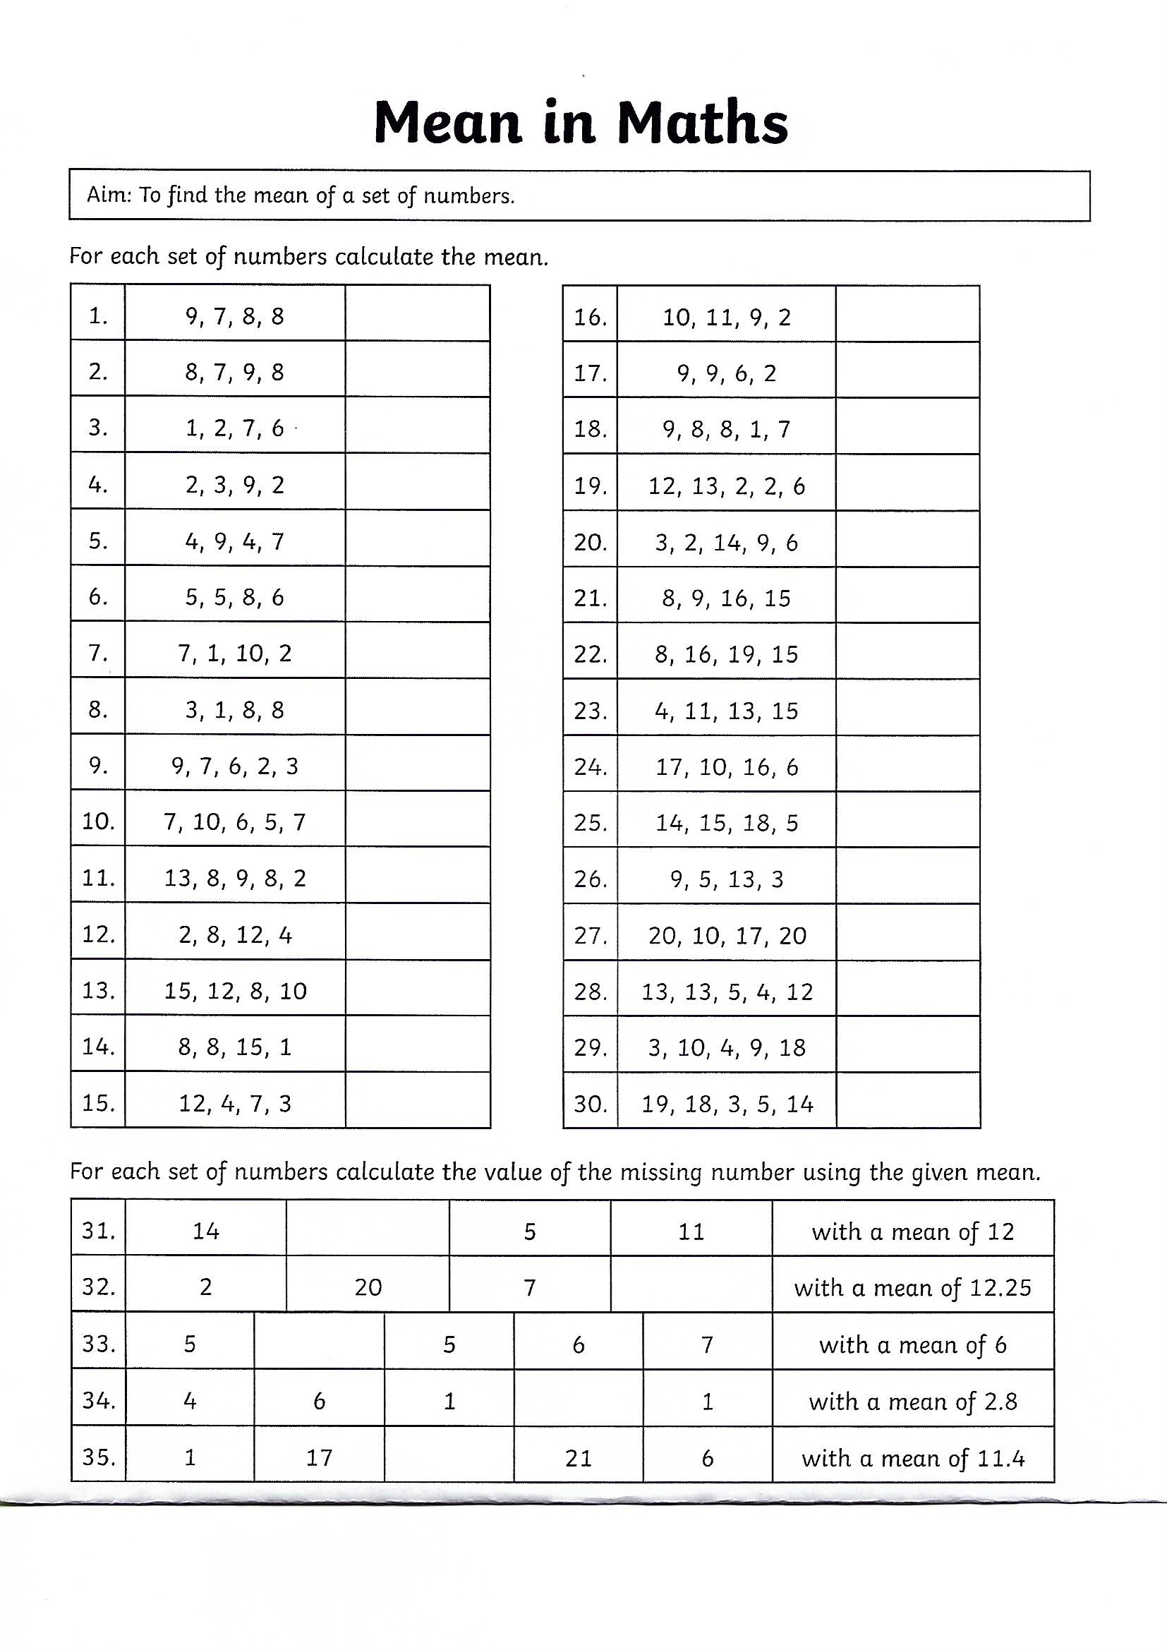

Numeracy Friday Primary 6
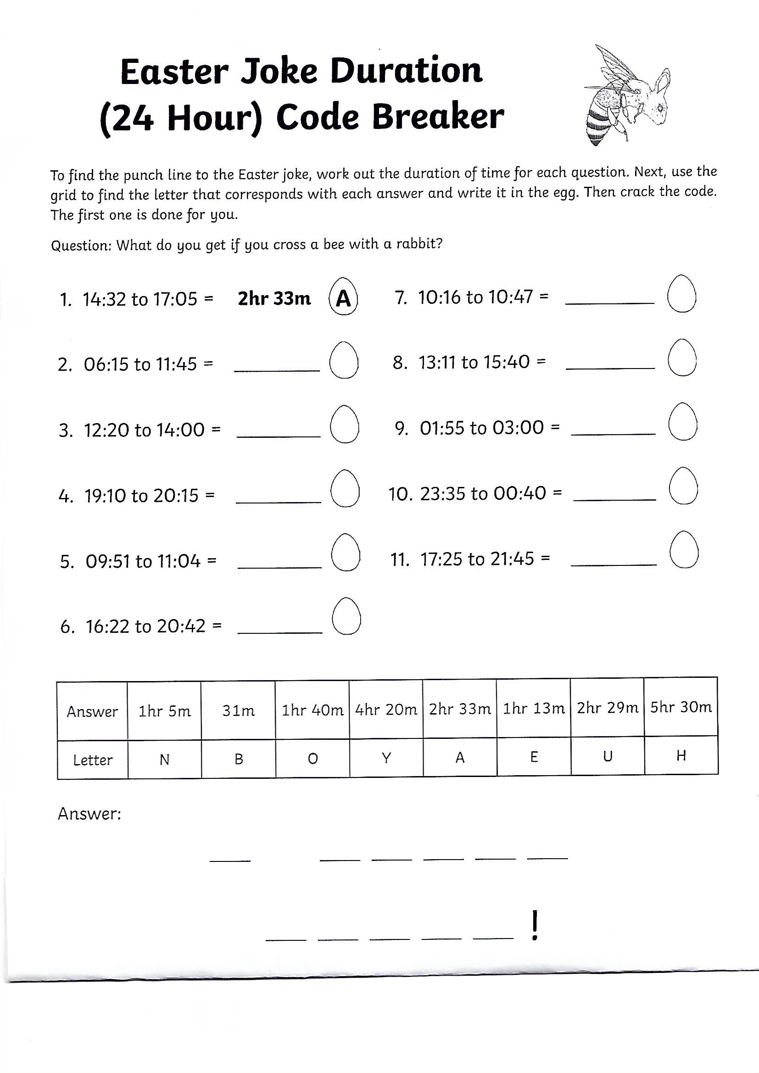
Most problem solving activities require modelling the activity to your child for the first two examples. Most children should be able to continue independently after this support.
Primary 7 Thursday and Friday – Problem Solving
This is a longer task so I have allowed two days for this. Go onto twinkl – still free access and download this problem solving activity called: The Mystery of the Contaminated Chocolate Easter Maths Mystery Game. See screenshots for guidance.
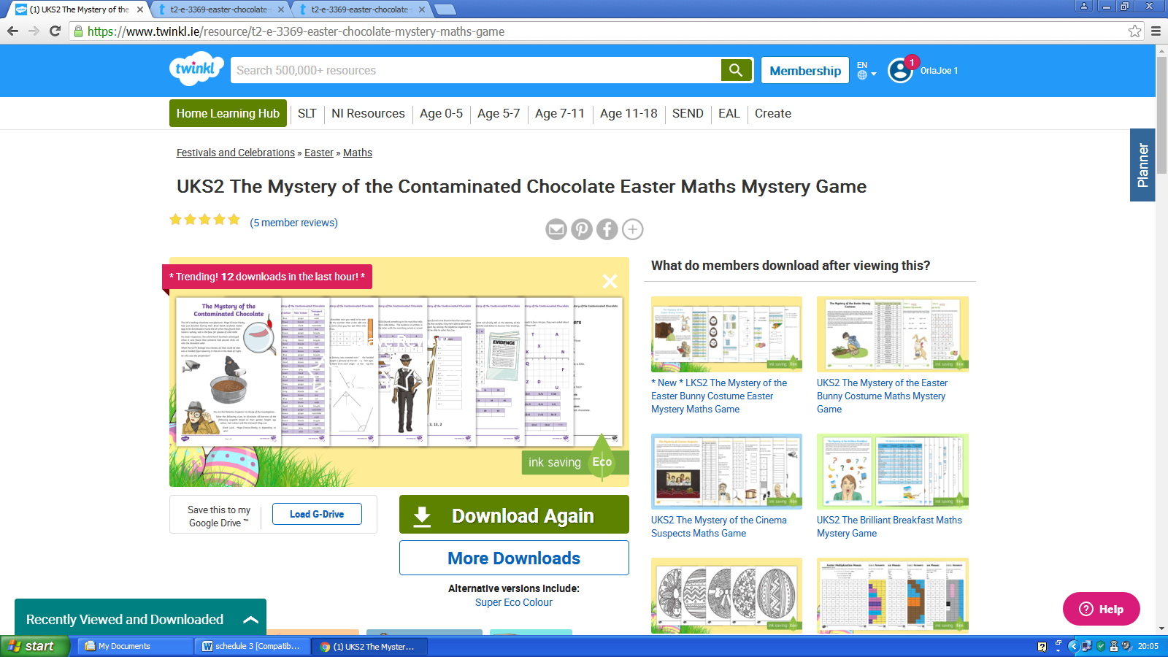

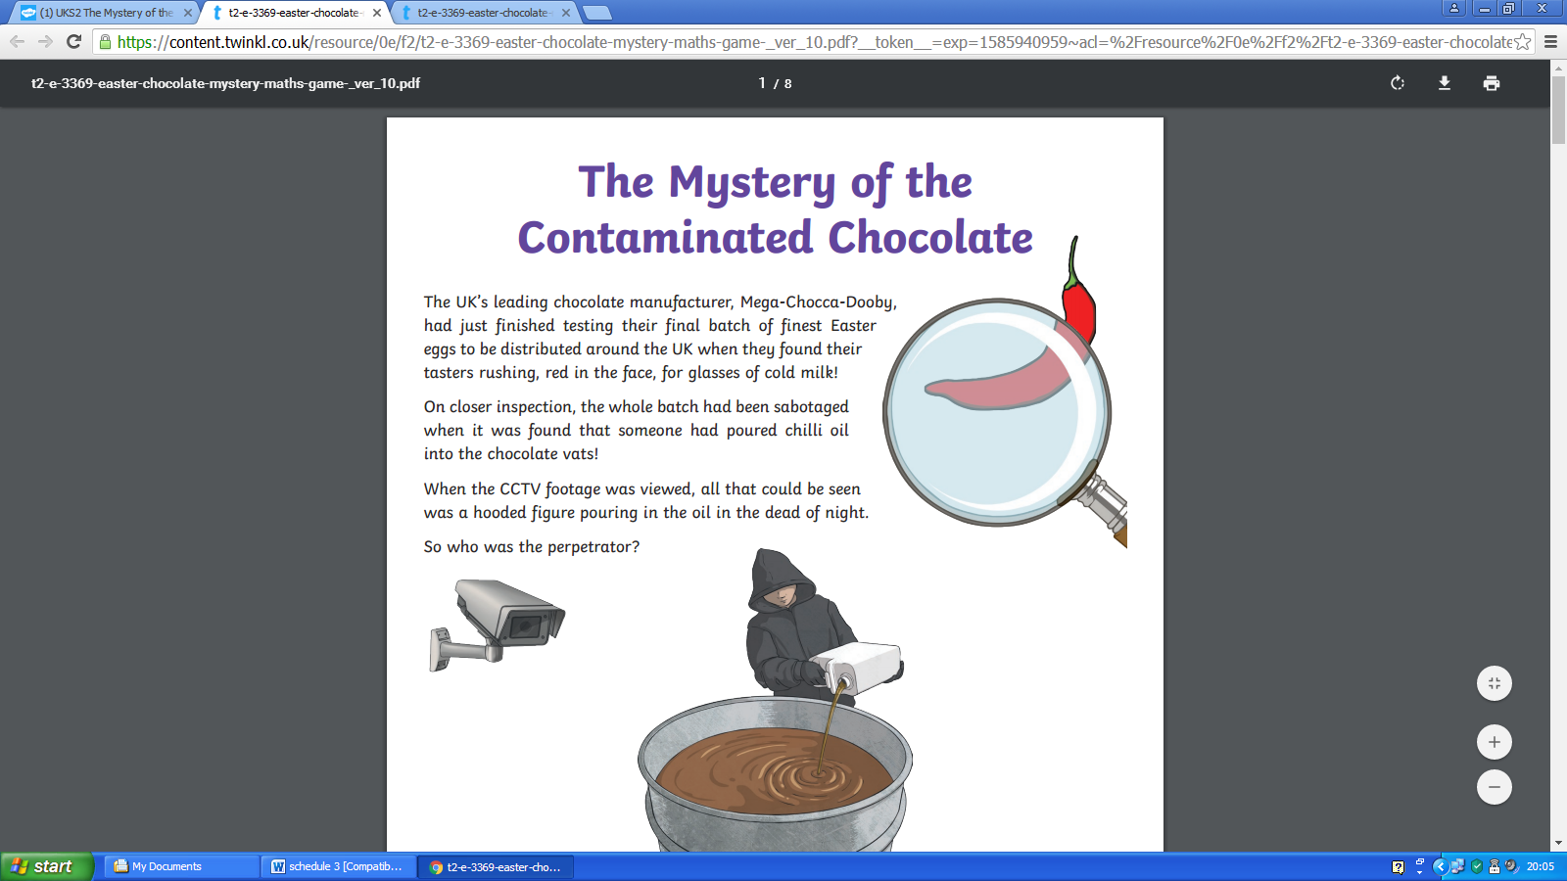

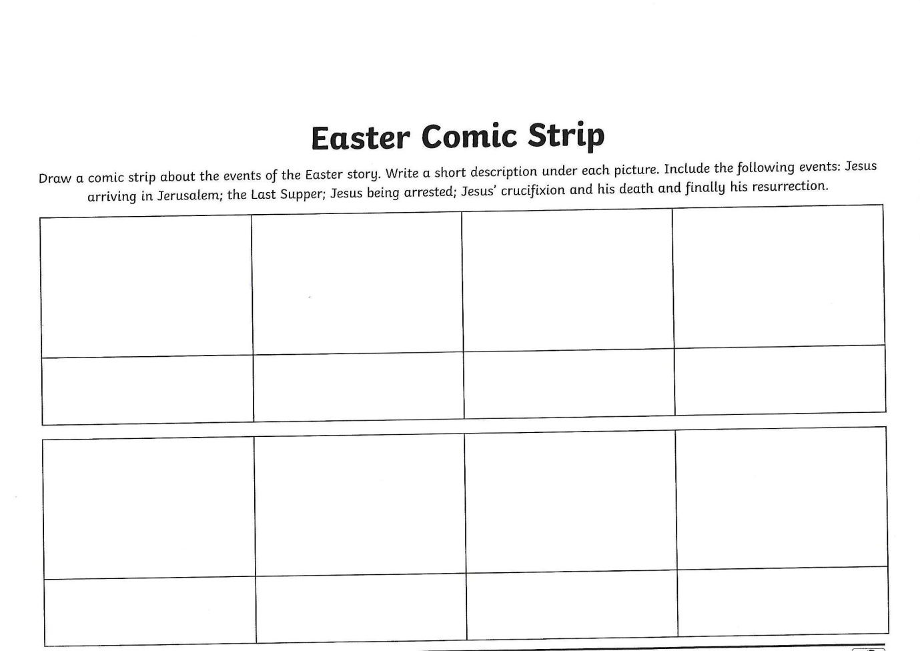
Religion Lesson – Wednesday

Paths Lesson - Thursday
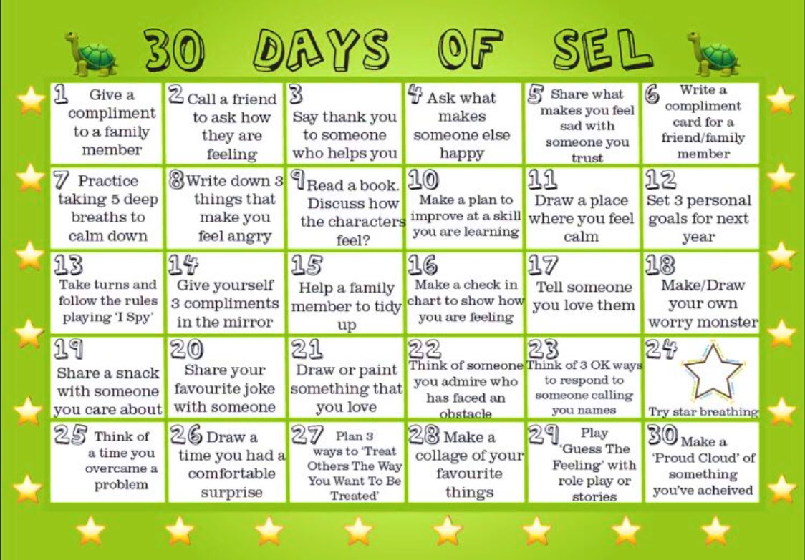

WAU – Monday Primary 6 and 7

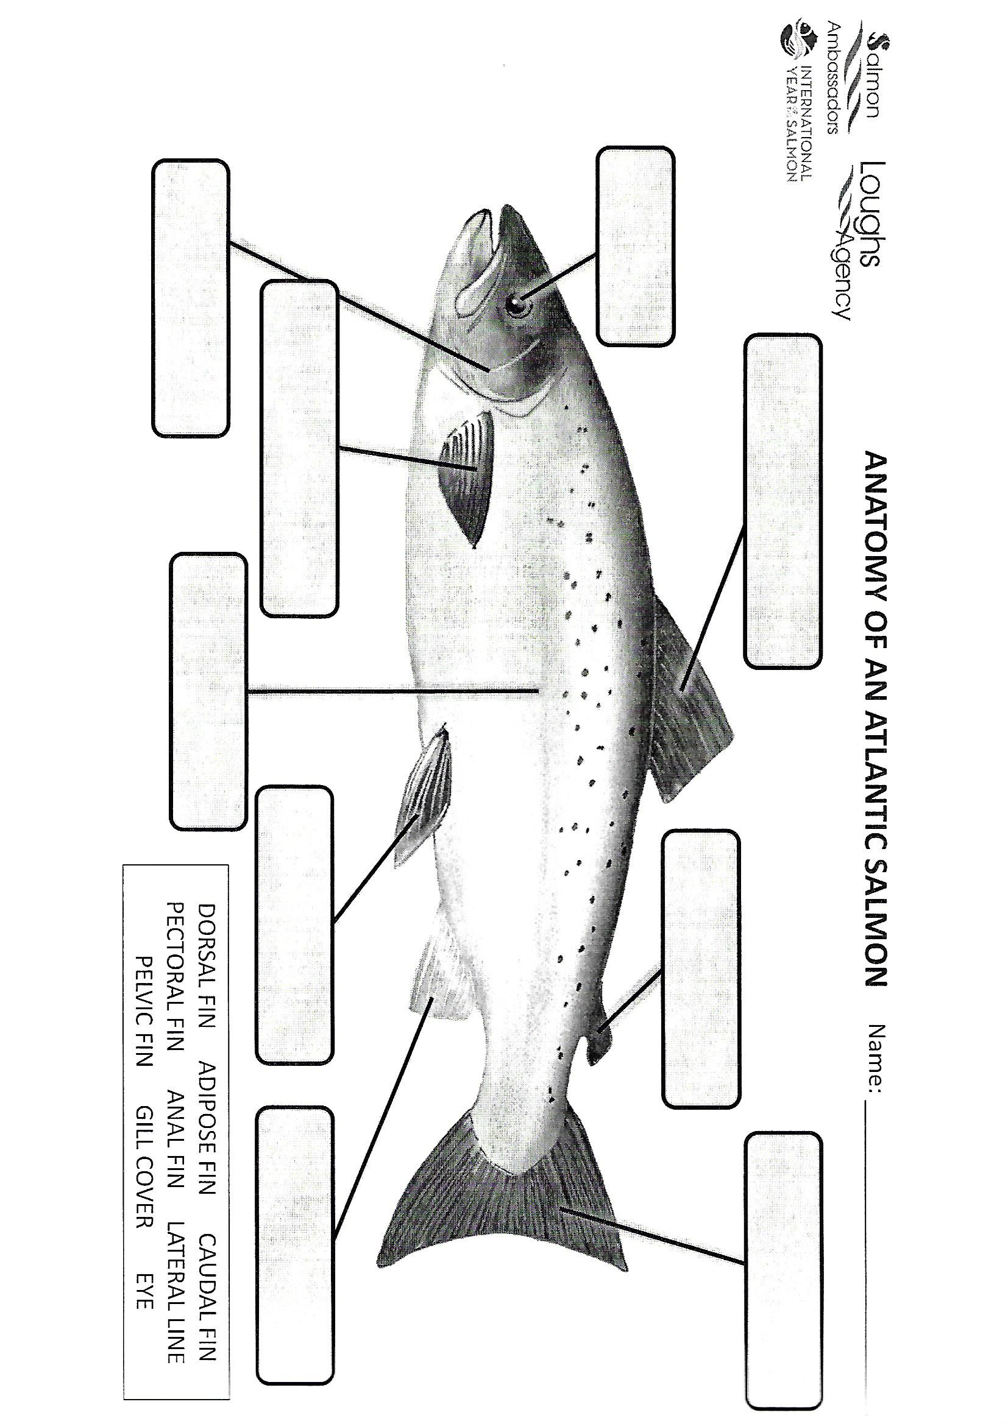
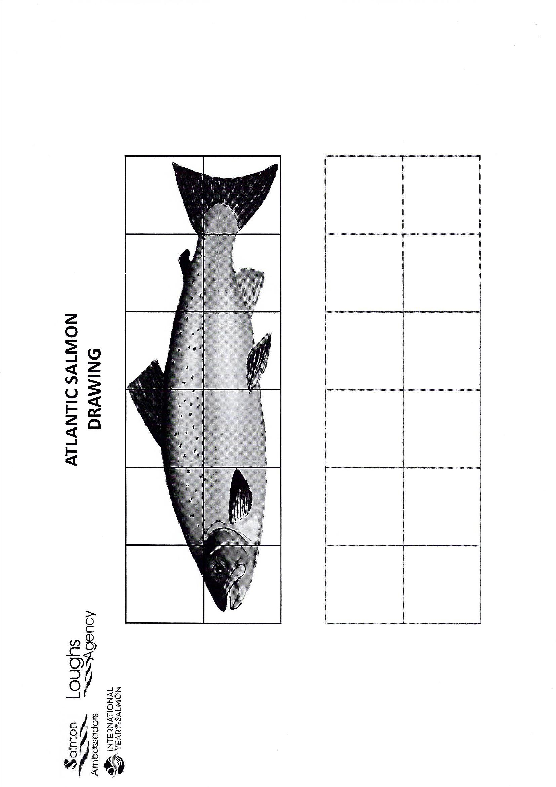

WAU – Thursday Primary 6 and 7
